OCNMS Manuscript: What I did with my summer vacations before covid ruined everything

Tolimieri, N.

Liu, O.

Sullaway, Gsul.

Samhouri, J.

Harvey, C..

Shelton, A.

Andrews, K.

Williams, G.

Lonhart, S.

Feisty B.

Frick, K.

Jenny?

Whoever else.. no particular order above; subject to change

# Abstract

TBW

# Introduction

Possible Intro outline:

1. Climate extremes challenging important ecosystems worldwide. Fires and forests, hurricanes and reefs, heat and kelp. Communities and people impacted
2. Kelp forests in NE Pacific and recent MHW
   1. Kelp forests in NE Pacific are important
   2. There have been a slew of papers looking at responses to the 2014-16 heatwave and the seastar dieoff. Big topics across the board seem to be 1) urchins & release from predation & effects on kelp; 2) kelp declines due to temperature
      1. Some talk about kelp being a sentinel and generally forecasting doom (Rogers-Bennett et al. 2019), some finding resilience due to the kelp forest community (Eisguirre Ecology), others finding a lot of spatial variation in kelp recovery (Cavanaugh Front. Mar. Sci.).
      2. We should look for a paper in the CA otter range (Monterey) to see what they think...
   3. Both of these have the same basic causality: big, external forcings (temperature, disease) that are driving change through time over large spatial scales.
   4. There is a gap in understanding what is going on in kelp forests of the PNW
3. Kelp forests in the PNW are important but here is what little we know
   1. Something about sea otters from Ole’s paper
   2. Seastars are predators on important grazers that modify kelp abundance (through space competition and/or herbivory). Challenged by recent disease outbreak.
   3. Fewer seastars could release sea urchins from predation pressure, especially in locations without sea otters (TI, NB).
   4. With more sea urchins, kelp could decline. Combined with MHW this could be a major negative impact on kelp.
   5. Less kelp could reduce rockfish recruitment.
4. Here we address the question of How do the northern coasts compare to the mess that is California? When we look across our surveys and species, do we see sweeping shared change?
   1. Note We don't have the pre-data to look at the magnitude of change due to the heatwave (except for a few Kvitek measurements of kelp density), but we do have the data to look at the post-heatwave just like we have the data to look at post-seastar.

Discussion topics.

1. PNW kelp forest communities do not appear to be as impacted by the seastar dieoff and MHW as much as more southern kelp forest communities. What might be buffering PNW communities?
   1. temperatures aren't so high up in washington - we're not near an edge.
   2. we have redundant kelp in a way that lots of California doesn't
   3. functional redundancy. We have otters + sea stars for predators.
2. Apology paragraph. Our monitoring began coincident with the 2014-16 marine heatwave, so we can't really test for impacts. But at a minimum the heatwave likely affected kelp and rockfish recruitment dynamics. Only possible way to think about impacts is to bring in WDNR data and/or Kviteck data to look more historically. Maybe bring these in to wave our hands about how the heat wave mixed stuff up?

Jamealian intro on climate and changing environment? 1 Para max or just a few sentences.

Kelp forests occur in nearshore, marine habitats throughout temperate waters (Dayton 1985, Steneck et al. 2002, Smale 2020). These communities are highly productive (Mann 1973) with kelp supporting nearshore food webs (Carr and Reed 2016, Yorke et al. 2019, Smale 2020, Chittaro et al. in preparation), and providing physical structure for array of vertebrate and invertebrate species (REF, Carr, Anderson, etc), especially juvenile rockfishes *Sebates* spp (REF). Other ecosystem effects include influencing sedimentation dynamics (Connell 2005), reducing wave energy (Pinsky et al. 2013), and providing carbon storage (Wilmers et al. 2012).

A range of abiotic and biotic factors influence the dynamics of kelp forest communities. Cool, nutrient rich waters promote high kelp cover, while warm, nutrient poor waters, and high wave energy can reduce kelp coverage (Pfister et al. 2018, Pinsky et al. 2019), sometimes dramatically (Rogers-Bennett and Catton 2019). At the same time, predators impose top-down forcing on herbivores and reducing herbivory and allowing kelp forests to persist. Along the west coast of North America, otters *Enhydra lutris*, urchins, and kelp form a well-studied and iconic trophic cascade (Estes et al. 2004, Watson and Estes 2011, Shelton et al. 2018). However, within this cascade, there is also a redundancy of predators. Large asteroids, especially *Pycnopodia helianthoides* are important urchin predators (Burt et al. 2018), as are California sheepshead *Semicossyphus pulcher* and spiny lobsters *Panulirus interruptus* in waters off of southern California (Beas-Luna et al. 2020, Eisaguirre et al. 2020). When these cascades are disrupted by climatic events or changes in predator or urchin density, the kelp forests can shift to an alternate stable state of urchin barrens, which may revert back to kelp forests with the reestablishment of predators or die offs of herbivores (Watson and Estes 2011, Shelton et al. 2018, Rogers-Bennett and Catton 2019, Williams et al. 2021).

Kelp forest communities along the west coast of North America have experience at least two major perturbations in the last decade. Starting in 2013 sea star wasting disease (SSWD) decimated asteroid populations of at least 20 species from California to Alaska leading to extensive reductions in population density, and in some cases, apparent local extinctions (Hewson et al. 2014, Montecino-Latorre et al. 2016, Hewson et al. 2018). As many of the hardest hit sea stars(*P. helianthoides* and *Pisaster* spp.) are urchin predators, the die off likely resulted in a reduction in top down pressure on urchins.

Concurrently, the eastern Pacific experienced a marine heat wave (MHW) from 2014-2016 (Bond et al. 2015, Jacox et al. 2018), which had profound effects on West Coast ecosystems including substantial losses of kelp cover in some regions. There were subsequent decreases red abalone Haliotis rufescens and red sea urchins *Mesocentrotus franciscanus* due to starvation, while purple urchin *Strongylocentrotus purpuratus* populations increased and their behavior shifted to active herbivory (Cavanaugh et al. 2019, Rogers-Bennett and Catton 2019, Smith et al. 2021). The MHW may have also exacerbated sea star die off (Harvell et al. 2019). Additionally, seabird mass mortality events (Piatt et al. 2020) and increases in whale entanglements in fishing gear due to habitat compression (Santora et al. 2020) were also associated with the MHW. This same period also saw changes in the ichthyoplankton (Nielsen et al. 2021), especially large increases in pelagic rockfish (*Sebastes* spp) juveniles off of the U.S. West Coast (Field et al. in press).

However, community responses to the combination of the sea star die-off and the MHW varied regionally (Cavanaugh et al. 2019, Beas-Luna et al. 2020). For example, kelp loss in northern California was substantial, likely due to the combined effects of high water temperatures, low otter densities, and a decrease in predatory sea stars (Rogers-Bennett and Catton 2019, Beas-Luna et al. 2020, McPherson et al. 2021). Central and southern Californian kelp forests were more resilient, possibly due to greater predator redundancy (Beas-Luna et al. 2020), while in Baja California reductions in kelp cover likely due to species being at the range margins (Meh). Similar variation in the dynamics of kelp forests occur at smaller scales as well (Eisaguirre et al. 2020).

Here, we examine responses of fish and integrate communities to the sea star die off and the recent marine heat wave at five kelp forest sites along the coast of Washington, U.S.A. from 2016-2019. We start by examining assemblage structure and relationships with habitat for fish and macroinvertebrates to better understand the importance of habitat, and spatial and temporal variation in these communities. We then highlight three vignettes related to the SSWD and MHW and kelp forest communities. First, we ask whether sea stars have shown any recovery from SSWD and examine relationships between sea star density and prey density. Second, we examine trends in urchin density and the relationship between urchins and kelp to determine whether the sea star die off lead to or allowed increases in urchin densities and subsequent reductions in kelp cover. Finally, we determine whether the high numbers of pelagic rockfish juveniles seen during the heat wave translated to higher recruitment in 2016, examine spatial patterns in recruitment, and distinguish whether different species complexes vary in their spatial and temporal patterns. As our data are limited to 2016-2019 we highlight changes (potentially recovery) in these communities following these events, but cannot measure direct impacts of the events themselves.

# Materials and Methods

## Study sites

We conducted dive surveys at five sites in late July or early August of 2016-2019 within the Olympic Coast National Marine Sanctuary (OCNMS, designated in 1994) along the coast of Washington, U.S.A. (Fig. 1). These sites span much of the OCNMS from Destruction Island in the south to Neah Bay in the north. Four sites were on the outer coast, while Neah Bay is within the Strait of Juan de Fuca and just outside of the OCNMS. All sites were relatively protected from wave action and had subtidal rocky reefs and supported kelp stands consisting of *Macrocystis pyrifera* and/or *Nerocystis luekana* as well as understory algae such as *Pterygophora californica* (Shelton et al. 2018).

## Survey design

At each site, we conducted visual surveys on scuba on 30 x 2 m transects to quantify: 1) fish abundance, 2) macroinvertebrate abundance, 3) kelp abundance, 4) other biotic habitat, and 5) substratum type (abiotic habitat, e.g., cobble, pavement, etc) (modified from Pondella et al. (2019)). At each site, we sample two locations, separated by 100+ m and marked by separate down lines, and two depths at each location (5 m and 10 m). One pair of divers sampled fish and quantified biotic habitat. The second pair of divers sampled macroinvertebrates and kelp and quantified substratum type. The lead diver laid down the transect tape and counted fish or macroinvertebrates and kelp. The second diver followed recording biotic habitat or substratum characteristics respectively. Both biotic habitat and substratum type were quantified using uniform point contact (UPC) methods by recording the organism or substratum directly under every meter mark along the transect for 30 data points per transect. Each pair of divers began transects from the same drop point marked by the down-line and followed the same overall heading. However, pairs did not necessarily cover the exact same ground, so one cannot directly match fish counts to substratum characteristics at the transect level, for example. Therefore, we often summarize data by year x site x depth for some analyses.

We counted and estimated the size (total length) of all fishes we observed within 2 m of the bottom and greater than 5 cm total length. The exception was rockfishes *Sebastes* spp, for which we estimated sizes for all individuals since we were interested in monitoring rockfish recruitment. Divers estimated visibility on each transect by determining the distance at which the lead diver could see the fingers their buddy. Transects with visibility less than 2.0 m were excluded from the analyses including fishes.

For biotic habitat, the diver recorded the organism directly under the transect every meter mark (universal point contact, UPC). Biotic habitat included the following functional groups: brown algae, red algae, green algae, encrusting species, diatom layer, eelgrass/surfgrass, non-mobile invertebrates, or non-living substratum (rock/sand).

Large mobile invertebrates were enumerated for individuals greater than 2.5 cm in diameter or width, with the exception of sea stars where we measured radius. We counted individuals under prostrate algae and within bottom topography and on algae up to a height of 1 m above the substrate. This category included species of sea urchins, sea star, sea cucumbers, crabs, bivalves, nudibranchs, etc. We included only species that were easily identifiable to avoid concerns about the detection of cryptic species. For abundant species the transect was broken into 10-m segments, and the distance at which 30 individuals were counted per segment was noted, to be used in expansion calculations. We also recorded sea urchin test diameter, sea star radius, and crab carapace width.

We counted canopy-forming kelp species within on the same transect as mancroinvertebrates. For *M. pyrifera* the stipes were counted when greater than 1 m in height. *N. luetkeana* and *Pterygophora californica* plants with stipes greater than 30 cm in height were included, along with other brown algae species greater than 30 cm in overall length. We again used the segment subsampling for abundant species described for invertebrate species.

We classified abiotic habitat (substratum) based on a simplified version of a system used extensively on the U.S. West Coast (Pearcy et al. 1989, Hixon et al. 1991, Stein et al. 1992, Greene et al. 1999, Tolimieri et al. 2008): sand, cobble, boulder, or bedrock; these features were recorded every meter (UPC). Additionally, we included an estimate of the slope every 10 m by estimating the drop in elevation across the 2-m width of the transect as: 0-10 cm, 10-100 cm, 1-2 m, or >2 m.

## Rockfish recruits

How we id them

## Sea stars and prey

We calculated separate sea star and prey indices by first examining sea star diets. For sea stars, we lumped all species but excluded *Henricia* spp because they eat primarily sponges and bacteria. Based on the sea star diets we lumped bivalves, shelled mollusks, shelled gastropods, and the three urchins to produce a prey index. We then plotted prey abundance against total sea start abundance.

## Urchins and Kelp

Expansion info?

# Results

* Jameal’s and Ole’s combined thoughts on figure outline
  + Fig 1. Conceptual schematic showing important interactions in WA kelp forests (silhouettes and arrows)
    - I would make sure to include all three major kelp species in this diagram (Nereo, Macro, Ptero)
  + Fig 2. Map
    - highlight more otters in 3 southern sites and fewer/no otters at TI and NB.
  + Fig 3. Time series of sea stars, sea urchins. Maybe seastar prey vs seastars.
    - Seastars show no sign of recovery and are at low abundance
    - Sea urchins increasing, especially at TI.
    - Add ordination plot (Fig. 3 currently) that show how broader communities clump by site, NOT by year 🡪 MHW/dieoff not driving seastar/urchin community structure
  + Fig 4. Time series of kelps and kelp vs urchins (add Kvitek data for historical baseline??)
    - Nereo declining, but sites doing different things 🡪 MHW/dieoff not driving kelp community structure
    - Less Nereo where there are more urchins at TI
    - Pairwise plots of Nereo v. Macro, Nereo v. Ptero, Macro v. Ptero? (competition / apparent competition). Helps us get to functional redundancy arguments in discussion
  + Fig 5. Time series of rockfish YOYs, multivariate analysis showing habitat does not help us understand variation in fish community composition
    - Copper dynamics diff than blk/yt, not covarying with kelp
    - Modified version of current Fig. 3 in manuscript, but just for rockfish, to show points clump by year, not so much by site???.
    - Is it worth making a paired set of plots for the non-YOY group? I'd be curious if they look more like inverts or more like the rockfish yoy.
* Open questions -
  + Worth bringing in Kvitek data?
  + Worth bringing in WDNR kelp data?
  + How do we deal with the "where are the otters" questions...

## Abiotic habitat

Sites varied in their abiotic substratum characteristics, and these differences were largely consistent across depth (Fig. S 1). The substratum at Destruction Island and Tatoosh Island comprised primarily bedrock; these sites also had high relief (Fig. S 2) relative to other sites with greater than 25% of the bottom having changes in elevation of >2 m across the width of the transects . The bottom at Neah Bay was also primarily bedrock, but the relief was much lower being primarily in the 10-cm to 1-m bin. At Cape Johnson and Cape Alava, boulder made up the most common substratum type and relief was generally low in the 10-cm to 1-m bin.

## Fish and invertebrate community structure

## We recorded 23 (non-cryptic) fish taxa on the transects (Table S 1Supplement table

Table S 1). Ten of these (Fig. S 5) were encountered frequently enough to be included in the ordination analyses. Fish assemblages differed among sites, depths, and years (dRDA, p < 0.001, Fig. 2). While there was variation among years for all sites, Cape Johnson ordinated separately from Cape Alava. Neah Bay and Tatoosh Island were intermediate between the previous two while Destruction Island assemblages were highly variable through time. Tubesnout (AUFL) were abundant at a subset of sites in 2016 and to a lesser extent in 2019. Greenlings (HEXA), copper rockfish (SECA), China rockfish (SENE), lingcod (OPEL), and cabezon (SCMA) characterized Cape Alava and Neah Bay, with the exception of 2016. Surfperch (EMBI) were also common at Cape Alava and at Cape Johnson, but only in 2017 and 2018 for the latter. Neah Bay, Tatoosh Island, and Cape Johnson did not show any temporal trends in the ordination with 2016 being much like 2019 (Fig. 2 and Fig. S 6). However, Cape Alava and Destruction Island showed some slight trends with 2019 having more rockfish, especially black rockfish (SEME) in 2019 than earlier. See Supplementary Material for more detail.

We grouped macroinvertebrates into 29 taxa and species (Fig. S 8, Fig. S 9, Fig. S 10, Fig. S 11). Community structure differed among sites (dRDA, p < 0.001, Fig. 3), and these differences were partly related to habitat characteristics (Fig. S 13). However, relationships between the invertebrate fauna and habitat largely driven by the three urchins and their relationship with macroalgae, with little pattern among the other macroinvertebrate species. All three urchin species showed positive associations with brown understory algae, *N. leukana*, *P. californica,* and other macroalgae and areas with boulder habitat (Fig. S 13). See Supplementary Material for more detail. Invertebrate assemblages showed little variation among years with year centroids for individual site clustering together and 2016 similar to 2019 (Fig. 3 and Fig. S 12). However, Destruction Island did show a slight temporal trend likely associated with a decrease in sea star density (Fig. 3 and Fig. S 12).

## Sea stars

Sea star abundance was highest at Destruction Island but generally low across other sites (Fig. 4). At Destruction Island, leather stars *Dermasterias imbricata*, ochre stars *Pisaster ocraceous,* and large sea stars all declined from 2016 – 2019, while brood sea stars *Leptasterias* spp increased at Destruction Island and Cape Johnson. *P. ocraceous* may have increased slightly at Tatoosh Island and Cape Alava from largely absent to present at very low density. Blood star *Henricia* spp densities remained fairly stable from 2016-2019. We did note a pulse of sea star recruitment in 2017, which was strongest in the south at Destruction Island and decreased with increasing latitude. Given the change in brood star densities, especially at Destruction Island and Cape Johnson, these were likely brood star recruits.

Among sites, prey abundance was declined at high sea star density at the transect level (GAM, p < 0.05, Fig. 5). Much of this relationship was due to differences among sites, especially Tatoosh and Destruction Islands. Prey items were most abundant but also highly variable (large variation along the y-axis in Fig. 5) at Tatoosh Island, where sea stars were less abundant. Sea stars were most abundant and also highly variable at Destruction Island and to a lesser extent Cape Alava, where prey was less abundant. Both sea stars and invertebrate prey were comparatively uncommon at Cape Johnson and Neah Bay.

## Macro-algae

There were three primary macroalgae found at the study sites: *M. pyrifera, N. leukana, P. californica.* We grouped the remaining macroalgae into an ‘other’ category due to rarity (Fig. 6). *M. pyrifera* was found on the 5-m transects at Cape Johnson and Neah Bay but was absent or less abundant in other areas. *N. leukana* was also more abundant at 5-m depths but was also found on 10-m transects at Tatoosh Island and Neah Bay. *N. leukana* was less common at Cape Johnson and Neah Bay that at other sites. *P. californica,* and under-story kelp, occurred at a sites at 5-m in similar abundance, although densities were slightly higher at Tatoosh Island and Neah Bay than other areas. *P. californica* was also found at 10-m at Tatoosh and Neah Bay.

## Urchins and kelp

Green, red, and purple urchins all showed increase in abundance from 2016 to 2017 at Tatoosh Island (Fig. S 8). Following this initial increase, both green and red urchins declined through 2019, while purple urchins remained abundant. Purple urchins also showed low densities but minor increases at Destruction Island from 2017-2019 (Fig. S 8). Qualitative observations and urchin test size distributions (measured in 2018 and 2019, Fig. S 15) suggest a recruitment pulse occurred sometime in 2017 or possibly early 2018.

Relationships between urchins and kelp differed among and within sites. Among sites urchins were negatively associated with *M. pyrifera* but positively associated with *N. luekana* as is evident from the first canonical axis in the invertebrate-habitat ordination (Fig. S 13). Sites with high abundance of *M. pyrifera* had few urchins (Fig. 7). However, this effect was largely due to the absence of *M. pyrifera* at Tatoosh Island, so the effect may geographical and not due to ecological interactions within the site.

The positive association between urchins and *N. leukana* among sites (Fig. S 13) stemmed from their both being found at Tatoosh Island (Fig. 7). However, within Tatoosh, the abundance of *N. leukana* was negatively correlated with the abundance of purple urchins (p = 0.015, r =0.53 , Fig. 7). Thus, as the densities of purple urchins increased at Tatoosh Island, kelp density decreased (Fig. 6). Interestingly, variability in the density of *P. californica* seemed to decrease with urchin density for both purple and red urchins (Fig. 7). The same was true for *N. leukana* and red urchins. For red urchins, the relationships may be partially spurious; red urchins increased then declined all while *N. pyrifera* declined likely due to grazing by purple urchins.

## Rockfish recruitment

Recruitment of rockfishes was temporally episodic (Fig. 8). While the intensity of recruitment varied among sites within a year, most species showed strong recruitment at multiple sites within a specific year. However, species had successful recruitment in different years. Black and yellow tail rockfishes showed strong recruitment at most sites in 2016 and to a lesser extent in 2019. This strong recruitment as especially Destruction Island and Cape Alava appears to have resulted in an increase in adult numbers at those sites seen both in the ordinations (Fig. 2 and Fig. S 6) and univariate plots (Fig. S 5). In contrast, copper rockfish (including unidentified recruits, which were most likely copper or quillback) had high recruitment at most sites in 2019. Canary recruitment pulses occurred in 2016 and 2018.

# Discussion

## Assemblage structure and habitat

Assemblage structure for fish and invertebrates differed among sites but was not strongly associated with habitat, apart from the association of urchins with *N. leukana* at Tatoosh. The sites were originally chosen as a suite of relatively similar, rocky-reef, kelp habitats with some shelter (Kvitek et al. 1989, Kvitek et al. 1998, Shelton et al. 2018), so the sites may not differ substantially in their habitat characteristics from the point of view of the fauna; they are all kelp forests. Instead, differences in assemblage structure may be related to other local processes like larval supply and interspecific interactions within sites leading to a diversity of assemblage structures. Interestingly, invertebrate assemblages showed little temporal variation in assemblage structure with individual sites having stable assemblage structure across years. Invertebrate densities declined substantially from the late 1980s to 2015, likely due to recolonization of these areas by sea otters (Shelton et al. 2018). Only Destruction Island showed evidence of any temporal trend due to the continued decline in sea star densities. Therefore, lack of substantial changes following the marine heatwave and sea star die off may be due to relatively low invertebrate densities limiting reproductive output and the potential for population growth.

## Sea stars and their prey

Sea star wasting disease caused substantial die-offs of asteroids from Mexico to Alaska between 2013-2015, including marked declines in abundance for most species on the Washington coast (Hewson et al. 2014, Menge et al. 2016, Montecino-Latorre et al. 2016, Hewson et al. 2018). Within the Salish Sea and on the Washington coast, there were concurrent increases in sea star prey like red and green urchin (Montecino-Latorre et al. 2016). Our data are largely post-die-off and show little evidence of recovery of sea star populations as of 2019. In fact, *P. ochraceous, D. imbricata,* and large sea stars continued to decline at Destruction Island and remained at low density at other sites. However, *Henricia* spp. densities were stable across years, and *Leptasterias* spp actually increased at the southern two sites, Cape Johnson and Destruction Island, likely due to recruitment at the site in 2017. However, large sea star densities tracked urchin densities at Tatoosh Island, increasing in 2017 and then dropping again in 2018 and 2019. The abundance of large sea stars also increased slightly from absent at Cape Johnson and Cape in 2016 to less than 0.05 individuals per 30x2 m transect in 2019.

Sea stars are important benthic predators in intertidal and subtitadal communities, and we might expect their rapid decline to have impacts on community structure and the abundance of prey species (Lubchenco and Menge 1978, Menge et al. 1994, Menge et al. 2016, Montecino-Latorre et al. 2016). Here, we saw a negative relationship between sea star density and the density of prey species, primarily urchins. At the larger scale, among sties, this relationship was driven largely by Tatoosh and Destruction Islands. Prey density was highest at Tatoosh Island where there were few sea stars (and few otters (Shelton et al. 2018)). Sea star densities were highest, and variable, at Destruction Island. Within Destruction Island, prey densities increased and became more variable as sea star densities decreased from 2016 to 2019, suggesting a release from top-down control. Thus both among and within sites, absence of sea stars appears to allow for increases in prey species, suggesting top-down pressure from the stars, but does not guarantee and increase in prey species. Among sites variability in recruitment due to climate and oceanic drivers almost certainly plays a large role.

## Urchins and kelp

We saw dramatic increases in all three urchins at Tatoosh Island from 2016 to 2017. Purple urchins increased almost four-fold from approximately 0.5 m-2 to almost 2.0 m-2, red urchins five-fold from circa 0.2 m-2 to 1.0 m-2, and green urchinsdoubled from approximately 0.4 m-2 to 0.8 m-2. Red and green urchins then declined, while purple urchin densities remained high. These increases were likely due to a recruitment pulse in 2017 given urchin sizes in 2018 and the changes in size from 2018-2019 (Tegner and Dayton 1981, Pearse and Hines 1987), but we do not have recruitment data for these species. Recruitment of purple urchins in northern California is associated with warmer SST conditions (Okamoto et al. 2020), so the marine heat wave in 2014-2016 may have contributed to a strong recruitment leading to the observed increases in 2017. Likewise, while the marine heat wave dissipated in 2017, some warm water remained off the US West Coast, including in the vicinity of Tatoosh Island (Harvey et al. 2018), potentially also leading to higher recruitment in 2017. Additionally, meso-scale habitat features like capes can create oceanographic features that may entrain and concentrate larvae leading to higher recruitment around promontories like Tatoosh Island/Cape Flattery (Danilowicz et al. 2001).

For purple urchins, recruitment pulses can lead to rapid increases in density (Pearse and Hines 1987, Pearse 2006), which can be short-lived and followed by rapid declines (50% within 1-yr) due to predation (Pearse and Hines 1987). Here, purple urchin numbers declined slightly in 2019 remained approximately twice that of 2017. Otters have not been common at Tatoosh Island in recent years (Shelton et al. 2018). We did see an increase in large sea stars at Tatoosh in 2017, but densities were still very low (~ 0.015 m-2). The lack of otters combined with the die off of predatory sea stars (Hewson et al. 2014, Montecino-Latorre et al. 2016) suggests that there were few predators at Tatoosh able to control urchin populations, which may have contributed to the persistent increase in purple urchin densities (Dunn and Hovel 2019, Eisaguirre et al. 2020). Red and green urchin density decreased rapidly after 2017 suggesting that other processes might have affected these species. Purple urchins do compete with red urchins (Tegner 2000, Pearse 2006), and it is possible the few large sea stars that were present in 2017 fed preferentially on red and green urchins releasing purple urchins from competition.

At large scale, there was a negative relationship between *M. pyrifera* and urchin densities for both purple and red urchins. This relationship is hard to interpret as *M. pyrifera* forest can be resilient to loss of sea otters and urchin grazing (Foster and Schiel 1988), and because the relationship it is driven primarily by the low *M. pyrifera* density and high urchin density at one site, Tatoosh Island. Nevertheless, high purple urchin density can lead to barrens, while die-offs have resulted in rapid re-forestation within six months in some areas (Williams et al. 2021). Conversely, at the large scale urchin abundance was highest at sites with *N. leukana and P. californica*, specific ally Tatoosh Island and Destruction Island in 2018 and 2019.

At Tatoosh Island, the increase in urchin densities coincided with a decrease in *N. leukana* on transects. Strong recruitment events can lead to intense grazing that would result in loss of kelp canopy (Watanabe and Harrold 1991). However, the dynamics can be more complex. In healthy kelp forests, urchins tend to move less, have higher gonadal-somatic index (GSI), and feed on drift kelp – acting as passive detritivores (Pearse 2006, Kriegisch et al. 2019, Smith et al. 2021) and functioning to transfer kelp detritus to other benthic consumers (Yorke et al. 2019). If kelp densities decrease, urchins switch to active herbivory, move more, have lower GSI, and are less appealing to otters as prey. Kelp canopy did decrease substantially along the Washington Coast in 2013-2015 (Shelton et al. 2018), likely due to the marine heat wave as warm temperatures tend to lead to loss of kelp (Pfister et al. 2018, Fewings and Brown 2019, Rogers-Bennett and Catton 2019). Thus it is possible that a change in urchin grazing behavior combined with a pulse of recruitment and few urchin predators lead to more, less cryptic urchins and active herbivory on *N. leukana* further precipitating the decline kelp at the transect level within Tatoosh. Interestingly, *P. californica* density increased at Tatoosh over the same suggesting that a decrease in canopy kelp may have allowed more light penetration and better growing conditions for the understory macroalgae.

## Rockfish recruits

The processes governing rockfish (*Sebaste*s spp) recruitment appear to operate at large spatial scales with many locations showing recruitment pulses in the same year. However, there is spatial variability in intensity within years, and the patterns differ among species with different life histories. For example, Field et al. (in press) found considerable spatial coherence in the relative abundance pelagic young-of-year (pre-recruits) of winter-spawning rockfishes associated with the shelf break in mid-water trawls along the West Coast of the US. In our data, recruitment was episodic and spatially variable, but individual taxon had recruitment pulses at most sites in a given year. Black rockfish and yellowtail rockfish had recruitment pulses at most sites in 2016, copper rockfish in 2019, and canary rockfish in 2016 and 2018. The intensity varied among sites within a year, with copper rockfish showing a latitudinal trend in recruitment in 2019. Density of copper recruits was highest at Destruction Island in the south and decreased as one moved north to Neah Bay (Fig. 8, panel SECAy). For black and yellowtail rockfishes, there was variability among sites, but no obvious latitude trend. In 2016, recruitment was high at Destruction Island in the south and at Neah Bay to the north (Fig. 8, panel SEBYTy).

The differences among taxa in their temporal patterns of recruitment appear related to the life-history of the species. Nearshore rockfishes follow two general life-histories: benthic-solitary species versus mid-water-aggregating species (Hyde and Vetter 2007, Markel and Shurin 2020). For solitary benthic species, good recruitment typically corresponds with warmer water and weak upwelling, which allows faster growth and onshore transport. The mid-water species have higher recruitment in cold water years with strong upwelling (Lenarz et al. 1995, Carr and Syms 2006). Copper rockfish fall in the CQB complex (copper, quillback, and brown rockfishes) of solitary, benthic species. Black and yellowtail rockfishes are aggregating mid-water species. Thus the peaks in recruitment in different years for we observed for these complexes is consistent with their life-history and previous observations. Off of Vancouver Island, Canada, the CQB complex had good recruitment in 2005, while black rockfishes had strong recruitment in 2006 (Markel and Shurin 2020). Consistent with previous observations (Lenarz et al. 1995, Carr and Syms 2006), these groups also responded differently to oceanographic conditions. High CQB recruitment in 2005 occurred during a period with prolonged downwelling and warm water temperature, and settlers had late parturition dates, fast presettlement growth, short pelagic durations, and small size at settlement. Strong upwelling and cool ocean temperatures were associated with the high black rockfish recruitment in 2006, when fish had slow pre-settlement growth and long pelagic durations (Markel and Shurin 2020).

The timing of settlement also differs among these groups, which likely affects their larval dynamics and interaction with oceanography. Yellow tail and black rockfish tend to settle between May and June, while fishes in the CQB complex settle later in July-October (Johansson et al. 2018, Ottmann et al. 2018). Interestingly, we did not see strong recruitment of copper rockfish in 2016, which was a warm year, but we did see high recruitment of black and yellowtail and rockfishes. However, in Oregon, there was strong recruitment of CQB fishes but much later in the year (September) than normal (Ottmann et al. 2018); our surveys would have missed this recruitment pulse. Source water is an important driver of rockfish recruitment (Schroeder et al. 2019), and anomalous oceanographic conditions may have upset more typical relationship. For example, overall, winter spawners showed high abundance during the years of the marine heat wave (Field et al. in press), which differs from what one might expect based on their normal association with colder, upwelling conditions.

## Bringing it all back home…

Overall, our data show a combination of large-scale temporal coherence for some processes but also important site-level variation. Dynamics related to oceanic scale processes and likely influenced by climate showed the temporal coherence. For example, sea stars had high recruitment at most sites in 2017, and rockfish showed high recruitment across sites within a given year, although the specific year differed among complexes. These results are consistent with other observations like the impact of the MHW on the abundance of rockfish pre-recruits (pelagic juveniles) (Field et al. in press) and the loss of canopy cover in kelp forests (Cavanaugh et al. 2019, Rogers-Bennett and Catton 2019, Beas-Luna et al. 2020), as well as the effects of water temperature on urchin recruitment (Okamoto et al. 2020).

Within this broad-scale temporal coherence is important site level variation. It is no surprise that recruitment was spatially variable within years; however, we saw two general patterns. Recruitment for sea stars and the copper-quillback-brown rockfish complex decreased from south to north, while the yellow tail-black rockfish complex did not demonstrate any latitudinal trend. Furthermore, there was site-level variation in other dynamics: urchins increased (and kelp declined) at Tatoosh Island, sea stars continued to decline in abundance at Destruction Island, and black rockfish showed substantial increases at Destruction Island (likely due to the observed recruitment).

Fish and invertebrate assemblages differed among sites, providing an array of somewhat different kelp forest communities along the Washington coast. We also saw different dynamics among sites with increased in urchins at Tatoosh Island with concurrent declines in kelp. While at Destruction Island, sea stars continued to decline in abundance. This portfolio effect (Schindler et al. 2015) may be important to both the overall ecology of the system and to the effective conservation and management of these marine resources by allowing for a range of responses to various perturbations. For example, while urchin barrens are generally considered a negative outcome (Eisaguirre et al. 2020, Williams et al. 2021), urchins are important food items for sea otters and *Pycnopodia* (as well as for spiny lobster and sheepshead in southern California), and they are important in the detrital food chain (Yorke et al. 2019). Urchin densities were generally low among our sites, but increased rapidly in 2017 at Tatoosh Island likely due to a combination of climate and oceanic influencing larval supply and to local-scale bethic biotic interactions. These urchins may serve as seed populations and provide propagules to other locations along the coast with low urchin densities. Thus when attempting to understand both the ecology of the system, and implementing conservation and management systems, ecologists and managers may need to take a portfolio approach to understanding the system and planning for the future.

# Acknowledgments

We thank XX anonymous reviewers and XX, XX, and XX for comments on the manuscript. More here: boat crew, coast guard at Neah Bay, etc.

# Literature Cited

Beas-Luna, R., F. Micheli, C. B. Woodson, M. Carr, D. Malone, J. Torre, C. Boch, J. E. Caselle, M. Edwards, J. Freiwald, S. L. Hamilton, A. Hernandez, B. Konar, K. J. Kroeker, J. Lorda, G. Montaño-Moctezuma, and G. Torres-Moye. 2020. Geographic variation in responses of kelp forest communities of the California Current to recent climatic changes. Global Change Biology **26**:6457-6473.

Bond, N. A., M. F. Cronin, H. Freeland, and N. Mantua. 2015. Causes and impacts of the 2014 warm anomaly in the NE Pacific. Geophysical Research Letters **42**:3414-3420.

Burt, J. M., M. T. Tinker, D. K. Okamoto, K. W. Demes, K. Holmes, and A. K. Salomon. 2018. Sudden collapse of a mesopredator reveals its complementary role in mediating rocky reef regime shifts. Proceedings of the Royal Society B-Biological Sciences **285**.

Carr, M. H., and D. C. Reed. 2016. Shallow Rocky Reefs and Kelp Forests. Pages 311-336 Ecosystems of California.

Carr, M. H., and C. Syms. 2006. Recruitment. Pages 411–427. *in* L. G. Allen, D. J. Pondella II, and M. H. Horn, editors. The ecology of marine fishes. University of California Press, Berkeley, California.

Cavanaugh, K. C., D. C. Reed, T. W. Bell, M. N. Castorani, and R. Beas-Luna. 2019. Spatial Variability in the Resistance and Resilience of Giant Kelp in Southern and Baja California to a Multiyear Heatwave. Frontiers in Marine Science **6**.

Chittaro, P., N. Tolimieri, K. Andrews, and Whoeverelse. in preparation. The stable isotope paper on rockfish. A really good one.

Clarke, K. R., and R. M. Warwick. 2001. Change in Marine Communities: An Approach to Statistical Analysis and Interpretation; 2nd edition. PRIMER-E, Plymouth, UK.

Connell, S. D. 2005. Assembly and maintenance of subtidal habitat heterogeneity: synergistic effects of light penetration and sedimentation. Marine Ecology Progress Series **289**:53-61.

Danilowicz, B. S., N. Tolimieri, and P. F. Sale. 2001. Meso-scale habitat features affect recruitment of reef fishes in St. Croix, US Virgin Islands. Bulletin of Marine Science **69**:1223-1232.

Dayton, P. K. 1985. The ecology of kelp communities. Annual Review of Ecology and Systematics **16**:251-245.

Dunn, R. P., and K. A. Hovel. 2019. Experiments reveal limited top-down control of key herbivores in southern California kelp forests. Ecology **100**:e02625.

Eisaguirre, J. H., J. M. Eisaguirre, K. Davis, P. M. Carlson, S. D. Gaines, and J. E. Caselle. 2020. Trophic redundancy and predator size class structure drive differences in kelp forest ecosystem dynamics. Ecology **101**:e02993.

Estes, J. A., E. M. Danner, D. F. Doak, B. Konar, A. M. Springer, P. D. Steinberg, M. T. Tinker, and T. M. Williams. 2004. Complex trophic interactions in kelp forest ecosystems. Bulletin of Marine Science **74**:621-638.

Fewings, M. R., and K. S. Brown. 2019. Regional Structure in the Marine Heat Wave of Summer 2015 Off the Western United States. Frontiers in Marine Science **6**.

Field, J., R. Miller, J. Santora, N. Tolimieri, M. Haltuch, R. Brodeur, T. Auth, E. J. Dick, K. Sakuma, and B. Wells. in press. Spatiotemporal patterns of variability in the abundance and distribution of winter-spawned pelagic juvenile rockfish in the California Current. TBD **TBD**.

Foster, M. S., and D. R. Schiel. 1988. Kelp communities and sea otters: keystone species or just another brick in the wall? Pages 92-115 *in* a. J. A. E. G. R. VanBlaricom, editor. The Community Ecology of Sea Otters. Springer-Verlag, Berlin.

Greene, H. G., M. M. Yoklavich, R. M. Starr, V. M. O'Connell, W. W. Wakefield, D. E. Sullivan, J. E. McRea, and G. M. Cailliet. 1999. A classification scheme for deep seafloor habitats. Oceanologica Acta **22**:663-678.

Harvell, C. D., D. Montecino-Latorre, J. M. Caldwell, J. M. Burt, K. Bosley, A. Keller, S. F. Heron, A. K. Salomon, L. Lee, O. Pontier, C. Pattengill-Semmens, and J. K. Gaydos. 2019. Disease epidemic and a marine heat wave are associated with the continental-scale collapse of a pivotal predator (<em>Pycnopodia helianthoides</em>). Science Advances **5**:eaau7042.

Harvey, C., N. Garfield, W. Williams, N. Tolimieri, I. Schroeder, E. Hazen, K. Andrews, K. Barnas, S. Bograd, R. Brodeur, B. Burke, J. Cope, L. deWitt, J. Field, J. Fisher, T. Good, C. Greene, D. Holland, M. Hunsicker, M. Jacox, S. Kasperski, S. Kim, A. Leising, S. Melin, C. Morgan, N. Muhling, S. Munsch, K. Norman, W. Peterson, M. Poe, J. Samhouri, W. Sydeman, J. Thayer, A. Thompson, D. Tommasi, A. Varney, B. Wells, T. Williams, J. Zamon, D. Lawson, S. Anderson, J. Gao, M. Litzow, S. McClatchie, E. Ward, and S. Zador. 2018. Ecosystem Status Report of the California Current for 2018: A Summary of Ecosystem Indicators Compiled by the California Current Integrated Ecosystem Assessment Team (CCEIA). U.S. Department of Commerce, NOAA Technical Memorandum NMFS-NWFSC-145.

Hewson, I., K. S. I. Bistolas, E. M. Quijano Cardé, J. B. Button, P. J. Foster, J. M. Flanzenbaum, J. Kocian, and C. K. Lewis. 2018. Investigating the Complex Association Between Viral Ecology, Environment, and Northeast Pacific Sea Star Wasting. Frontiers in Marine Science **5**.

Hewson, I., J. B. Button, B. M. Gudenkauf, B. Miner, A. L. Newton, J. K. Gaydos, J. Wynne, C. L. Groves, G. Hendler, M. Murray, S. Fradkin, M. Breitbart, E. Fahsbender, K. D. Lafferty, A. M. Kilpatrick, C. M. Miner, P. Raimondi, L. Lahner, C. S. Friedman, S. Daniels, M. Haulena, J. Marliave, C. A. Burge, M. E. Eisenlord, and C. D. Harvell. 2014. Densovirus associated with sea-star wasting disease and mass mortality. Proc Natl Acad Sci U S A **111**:17278-17283.

Hixon, M. A., B. N. Tissot, and W. G. Pearcy. 1991. Fish assemblages of rocky banks of the Pacific Northwest, Final Report, OCS Study 91-0052. U. S. Minerals Management Service, Camarillo, California.

Hyde, J. R., and R. D. Vetter. 2007. The origin, evolution, and diversification of rockfishes of the genus Sebastes (Cuvier). Mol Phylogenet Evol **44**:790-811.

Jacox, M. G., M. A. Alexander, N. J. Mantua, J. D. Scott, G. Hervieux, R. S. Webb, and F. E. Werner. 2018. Forcing of Multiyear Extreme Ocean Temperatures That Impacted California Current Living Marine Resources in 2016. Bulletin of the American Meteorological Society **99**:S27-S33.

Johansson, M. L., M. N. C. Litz, R. D. Brodeur, T. A. Britt, C. A. Vanegas, J. R. Hyde, and M. A. Banks. 2018. Seasonal distribution of late larval and juvenile rockfish (Sebastes spp.) and associated environmental conditions off Oregon and Washington: new insights based on genetics. Fishery Bulletin **116**:266-280.

Kriegisch, N., S. E. Reeves, E. B. Flukes, C. R. Johnson, and S. D. Ling. 2019. Drift-kelp suppresses foraging movement of overgrazing sea urchins. Oecologia **190**:665-677.

Kvitek, R. G., P. Iampietro, and C. E. Bowlby. 1998. Sea Otters and Benthic Prey Communities: A Direct Test of the Sea Otter as Keystone Predator in Washington State. Marine Mammal Science **14**:895-902.

Kvitek, R. G., D. Shull, D. Canestro, E. C. Bowlby, and B. L. Troutman. 1989. Sea Otters and Benthic Prey Communities in Washington State. Marine Mammal Science **5**:266-280.

Legendre, P., and M. J. Anderson. 1999. Distance-based redundancy analysis: testing multispecies responses in multifactorial ecological experiments. Ecological Monographs **69**:1-24.

Lenarz, W. H., D. A. Ventresca, W. M. Graham, F. B. Schwing, and F. Chavez. 1995. Explorations of El Nino events and associated biological population dynamics off central California. California Cooperative Oceanic Fisheries Investigations Reports **36**:106-119.

Lubchenco, J., and B. A. Menge. 1978. Community development and persistence in a low rocky intertidal zone. Ecological Monographs **48**:67-94.

Mann, K. H. 1973. Seaweeds: Their Productivity and Strategy for Growth. Science **182**:975-981.

Markel, R. W., and J. B. Shurin. 2020. Contrasting effects of coastal upwelling on growth and recruitment of nearshore Pacific rockfishes (genus Sebastes). Canadian Journal of Fisheries and Aquatic Sciences **77**:950-962.

McPherson, M. L., D. J. I. Finger, H. F. Houskeeper, T. W. Bell, M. H. Carr, L. Rogers-Bennett, and R. M. Kudela. 2021. Large-scale shift in the structure of a kelp forest ecosystem co-occurs with an epizootic and marine heatwave. Communications Biology **4**.

Menge, B. A., E. L. Berlow, C. A. Blanchette, S. A. Navarrete, and S. B. Yamada. 1994. The keystone species concept: variation in interaction strength in a rocky intertidal habitat. Ecological Monographs **64**:249-286.

Menge, B. A., E. B. Cerny-Chipman, A. Johnson, J. Sullivan, S. Gravem, and F. Chan. 2016. Sea Star Wasting Disease in the Keystone Predator Pisaster ochraceus in Oregon: Insights into Differential Population Impacts, Recovery, Predation Rate, and Temperature Effects from Long-Term Research. PLoS One **11**:e0153994.

Montecino-Latorre, D., M. E. Eisenlord, M. Turner, R. Yoshioka, C. D. Harvell, C. V. Pattengill-Semmens, J. D. Nichols, and J. K. Gaydos. 2016. Devastating Transboundary Impacts of Sea Star Wasting Disease on Subtidal Asteroids. PLoS One **11**:e0163190.

Nielsen, J. M., L. A. Rogers, R. D. Brodeur, A. R. Thompson, T. D. Auth, A. L. Deary, J. T. Duffy-Anderson, M. Galbraith, J. A. Koslow, and R. I. Perry. 2021. Responses of ichthyoplankton assemblages to the recent marine heatwave and previous climate fluctuations in several Northeast Pacific marine ecosystems. Global Change Biology **27**:506-520.

Okamoto, D. K., S. C. Schroeter, and D. C. Reed. 2020. Effects of ocean climate on spatiotemporal variation in sea urchin settlement and recruitment. Limnology and Oceanography **65**:2076-2091.

Ottmann, D., K. Grorud-Colvert, B. Huntington, and S. Sponaugle. 2018. Interannual and regional variability in settlement of groundfishes to protected and fished nearshore waters of Oregon, USA. Marine Ecology Progress Series **598**:131-145.

Pearcy, W. G., D. L. Stein, M. A. Hixon, E. K. Pikitch, W. H. Barss, and R. M. Starr. 1989. Submersible observations of deep-reef fishes of Heceta Bank Oregon USA. Fishery Bulletin **87**:955-966.

Pearse, J. S. 2006. Ecological role of purple sea urchins. Science **314**:940-941.

Pearse, J. S., and A. H. Hines. 1987. Long-term population dynamics of sea urchins in a central California kelp forest: rare recruitment and rapid decline. Marine Ecology Progress Series **39**:275-283.

Pfister, C. A., H. D. Berry, T. Mumford, and A. Randall Hughes. 2018. The dynamics of Kelp Forests in the Northeast Pacific Ocean and the relationship with environmental drivers. Journal of Ecology **106**:1520-1533.

Piatt, J. F., J. K. Parrish, H. M. Renner, S. K. Schoen, T. T. Jones, M. L. Arimitsu, K. J. Kuletz, B. Bodenstein, M. Garcia-Reyes, R. S. Duerr, R. M. Corcoran, R. S. A. Kaler, G. J. McChesney, R. T. Golightly, H. A. Coletti, R. M. Suryan, H. K. Burgess, J. Lindsey, K. Lindquist, P. M. Warzybok, J. Jahncke, J. Roletto, and W. J. Sydeman. 2020. Extreme mortality and reproductive failure of common murres resulting from the northeast Pacific marine heatwave of 2014-2016. Plos One **15**.

Pinsky, M. L., A. M. Eikeset, D. J. McCauley, J. L. Payne, and J. M. Sunday. 2019. Greater vulnerability to warming of marine versus terrestrial ectotherms. Nature **569**:108-+.

Pinsky, M. L., G. Guannel, and K. K. Arkema. 2013. Quantifying wave attenuation to inform coastal habitat conservation. Ecosphere **4**:art95.

Pondella, D. J., II, S. E. Piacenza, J. T. Claisse, C. M. Williams, J. P. Williams, A. J. Zellmer, and J. E. Caselle. 2019. Assessing drivers of rocky reef fish biomass density from the Southern California Bight. Marine Ecology Progress Series **628**:125-140.

R Core Team. 2020. R: A language and environment for statistical computing. R Foundation for Statistical Computing, Vienna, Austria. URL <https://www.R-project.org/>.

Rogers-Bennett, L., and C. A. Catton. 2019. Marine heat wave and multiple stressors tip bull kelp forest to sea urchin barrens. Sci Rep **9**:15050.

Santora, J. A., N. J. Mantua, I. D. Schroeder, J. C. Field, E. L. Hazen, S. J. Bograd, W. J. Sydeman, B. K. Wells, J. Calambokidis, L. Saez, D. Lawson, and K. A. Forney. 2020. Habitat compression and ecosystem shifts as potential links between marine heatwave and record whale entanglements. Nature Communications **11**:536.

Schindler, D. E., J. B. Armstrong, and T. E. Reed. 2015. The portfolio concept in ecology and evolution. Frontiers in Ecology and the Environment **15**:257-263.

Schroeder, I. D., J. A. Santora, S. J. Bograd, E. L. Hazen, K. M. Sakuma, A. M. Moore, C. A. Edwards, B. K. Wells, and J. C. Field. 2019. Source water variability as a driver of rockfish recruitment in the California Current Ecosystem: implications for climate change and fisheries management. Canadian Journal of Fisheries and Aquatic Sciences **76**:950-960.

Shelton, A. O., C. J. Harvey, J. F. Samhouri, K. S. Andrews, B. E. Feist, K. E. Frick, N. Tolimieri, G. D. Williams, L. D. Antrim, and H. D. Berry. 2018. From the predictable to the unexpected: kelp forest and benthic invertebrate community dynamics following decades of sea otter expansion. Oecologia **188**:1105-1119.

Smale, D. A. 2020. Impacts of ocean warming on kelp forest ecosystems. New Phytologist **225**:1447-1454.

Smith, J. G., J. Tomoleoni, M. Staedler, S. Lyon, J. Fujii, and M. T. Tinker. 2021. Behavioral responses across a mosaic of ecosystem states restructure a sea otter-urchin trophic cascade. Proc Natl Acad Sci U S A **118**.

Stein, D. L., B. N. Tissot, M. A. Hixon, and W. Barss. 1992. Fish-habitat associations on a deep reef at the edge of the Oregon continental-shelf. Fishery Bulletin **90**:540-551.

Steneck, R. S., M. H. Graham, B. J. Bourque, D. Corbett, J. M. Erlandson, J. A. Estes, and M. J. Tegner. 2002. Kelp forest ecosystems: biodiversity, stability, resilience and future. Environmental Conservation **29**:436-459.

Tegner, M. 2000. Ecosystem effects of fishing in kelp forest communities. ICES Journal of Marine Science **57**:579-589.

Tegner, M. J., and P. K. Dayton. 1981. Population Structure, Recruitment and Mortality of Two Sea Urchins (Strongylocentrotus franciscanus and S. purpuratus) in a Kelp Forest. Marine Ecology Progress Series **5**:255-268.

Tolimieri, N., M. E. Clarke, H. Singh, and C. Goldfinger. 2008. Evaluating the SeaBED AUV for Monitoring Groundfish in Untrawlable Habitat. Pages 129-142 *in* J. R. Reynolds and H. G. Greene, editors. Marine Habitat Mapping Technology for Alaska. Alaska Sea Grant College Program, University of Alaska Fairbanks.

Watanabe, J. M., and C. Harrold. 1991. Destructive grazing by sea urchins Strongylocentrotus spp. in a central California kelp forest: potential roles of recruitment, depth, and predation. Marine Ecology Progress Series **71**:125-141.

Watson, J., and J. A. Estes. 2011. Stability, resilience, and phase shifts in rocky subtidal communities along the west coast of Vancouver Island, Canada. Ecological Monographs **81**:215-239.

Williams, J. P., J. T. Claisse, D. J. Pondella, II, C. M. Williams, M. J. Robart, Z. Scholz, E. M. Jaco, T. Ford, H. Burdick, and D. Witting. 2021. Sea urchin mass mortality rapidly restores kelp forest communities. Marine Ecology Progress Series **664**:117-131.

Wilmers, C. C., J. A. Estes, M. Edwards, K. L. Laidre, and B. Konar. 2012. Do trophic cascades affect the storage and flux of atmospheric carbon? An analysis of sea otters and kelp forests. Frontiers in Ecology and the Environment **10**:409-415.

Yorke, C. E., H. M. Page, and R. J. Miller. 2019. Sea urchins mediate the availability of kelp detritus to benthic consumers. Proc Biol Sci **286**:20190846.

# Figures

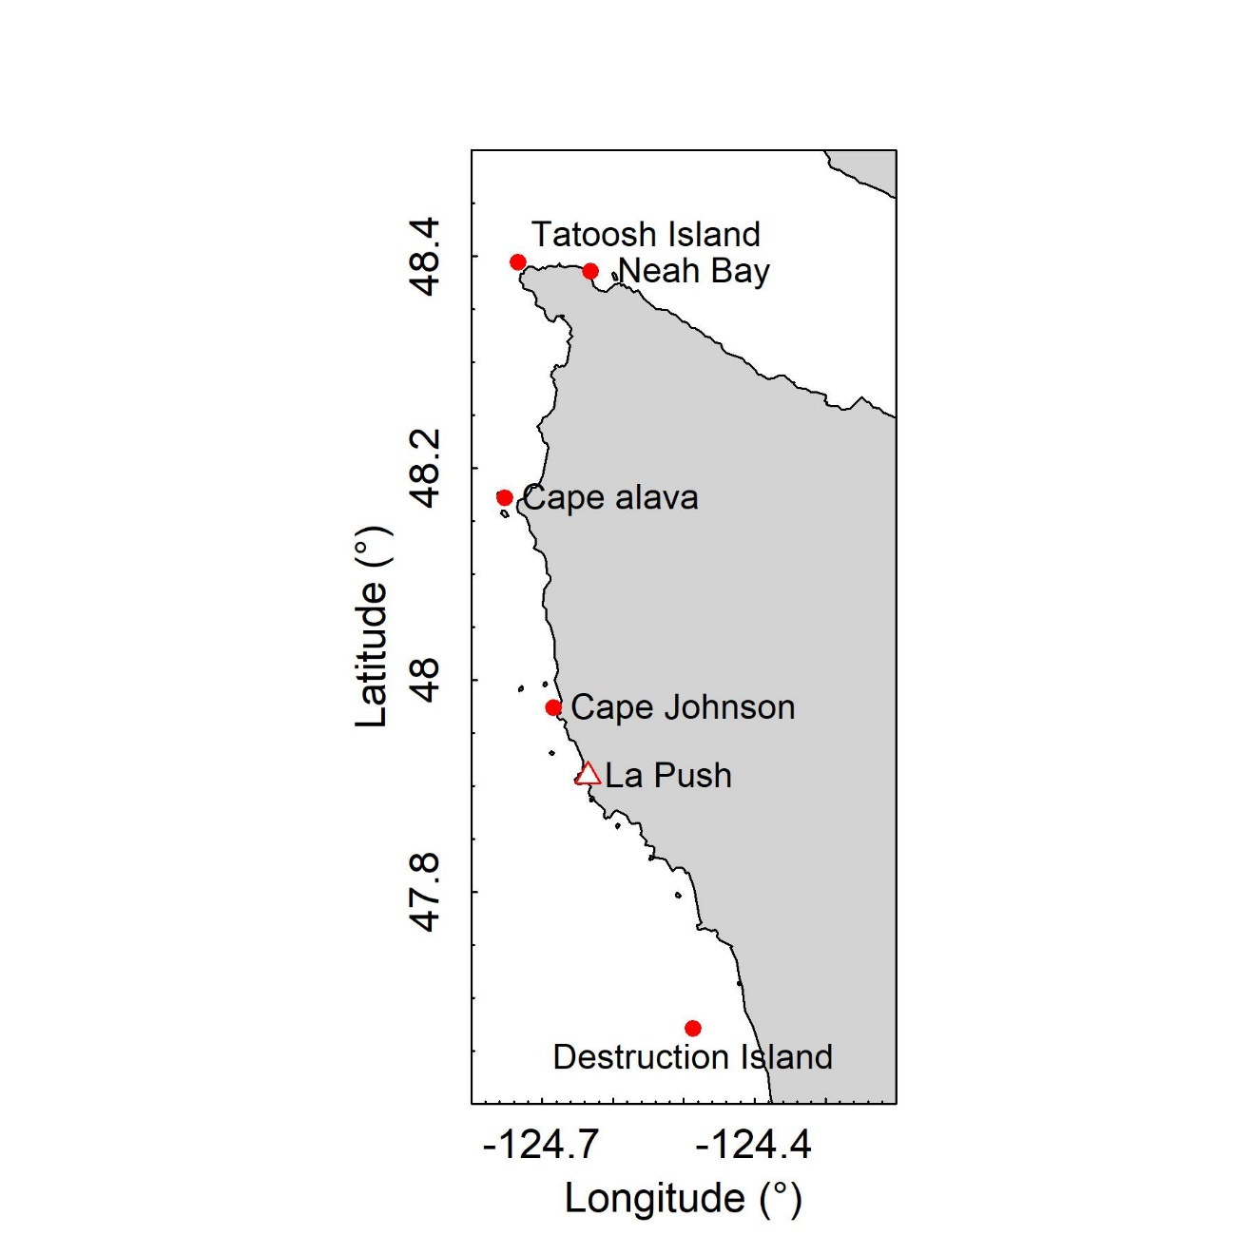

Fig. 1 Location of study sites. The town of La Push is included for reference, but is not a sampling site.

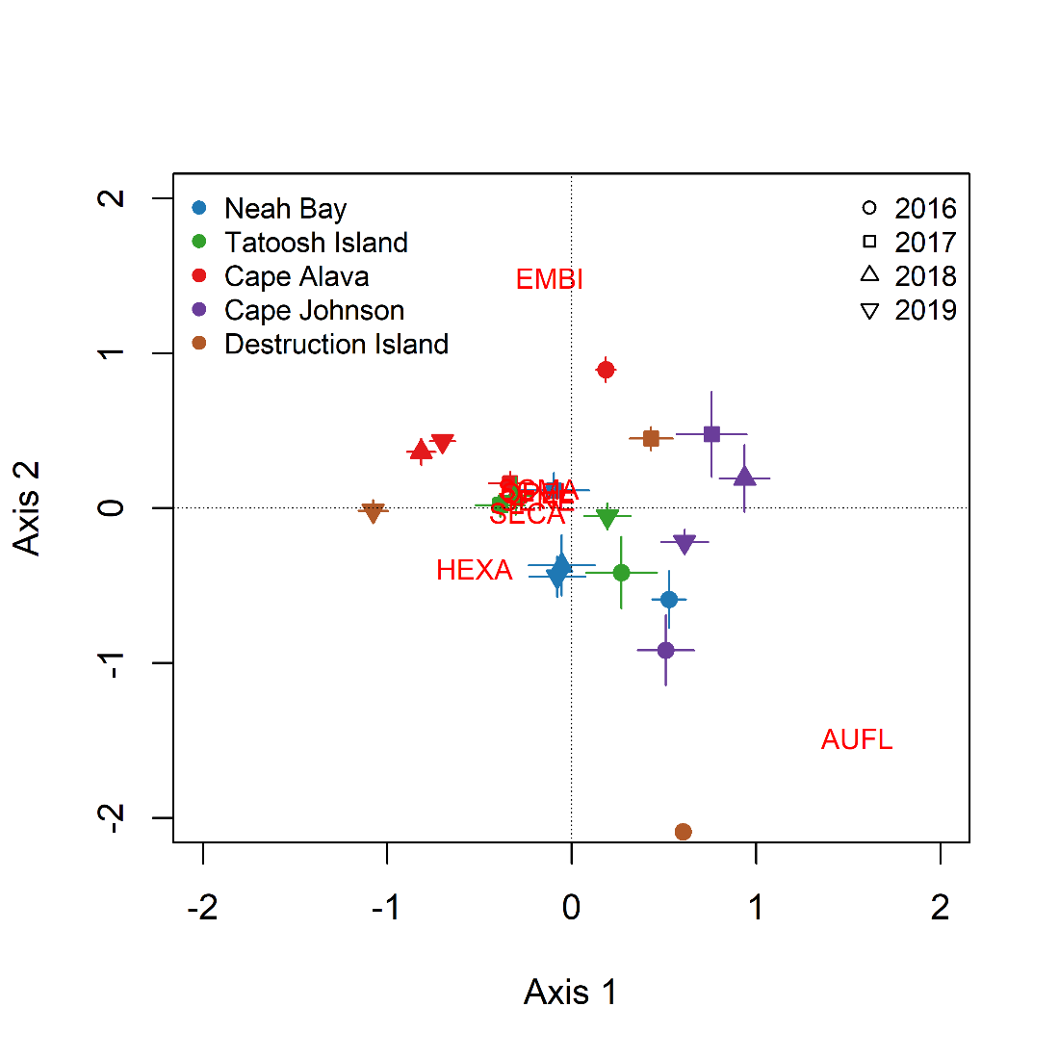

Fig. 2 Ordination of sites based on the fish taxa present on 30 x 2 m transects from a distanced-based redundancy analysis. The analysis used individual transects, but the axes were averaged by site and year for clarity in the presentation. Error bars indicate ± 1.0 s.e. Red text shows the loadings for fish taxa. The overlapping taxa just left of the center are: SCMA, SENE, SECA, OPEL. See XX for taxa designations.

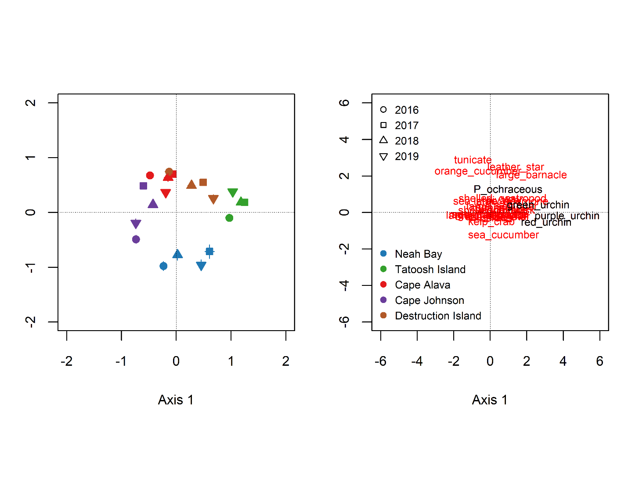

Fig. 3 Ordination of sites based on the invertebrate taxa present on 30 x 2 m transects from a distanced-based redundancy analysis. The analysis used individual transects, but the axes were averaged by site and year for clarity in the presentation. Error bars indicate ± 1.0 s.e. In most cases, error bars are smaller than the points. The results are presented in two panes with the species loadings plotted on the second pane for readability. Species colors on the loadings pane are for readability and used to emphasize particular species.

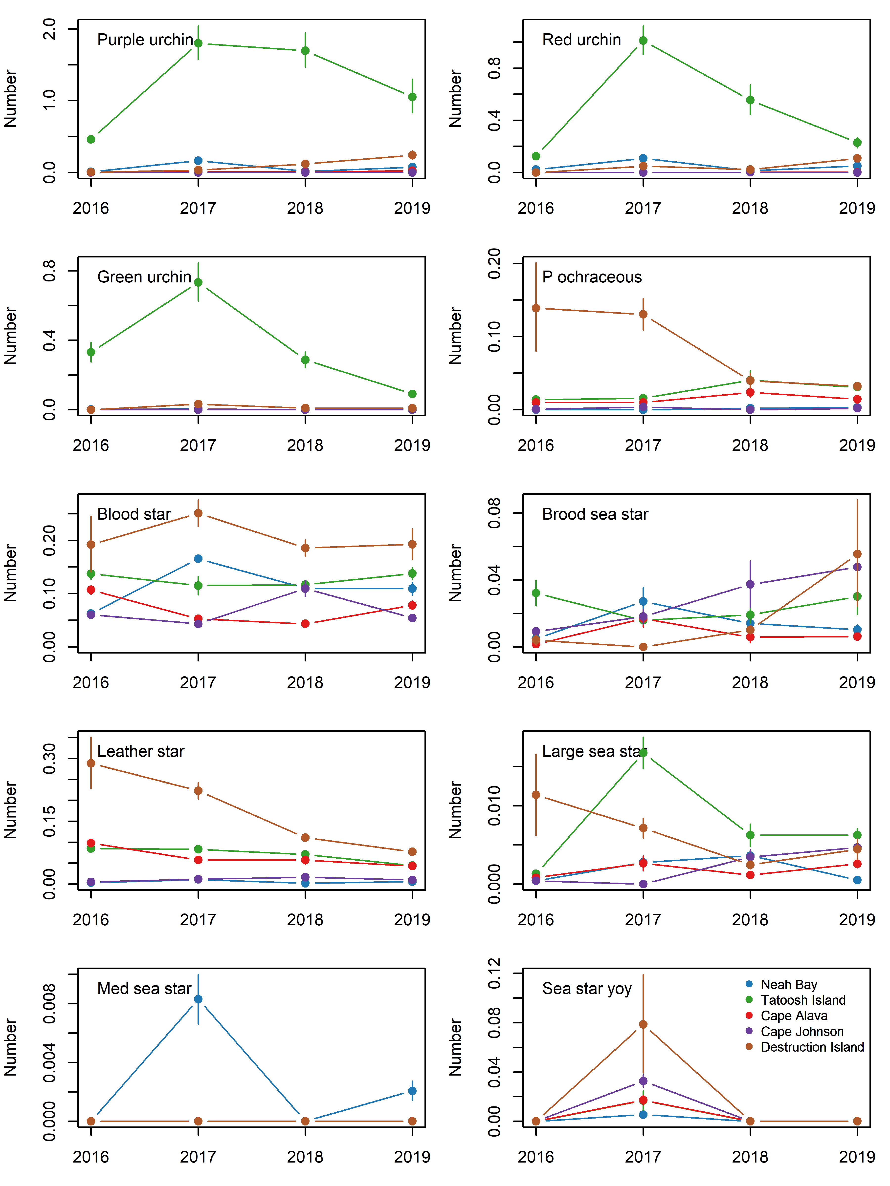

Fig. 4 Abundance (number per m2) of individual urchin and sea star species through time.

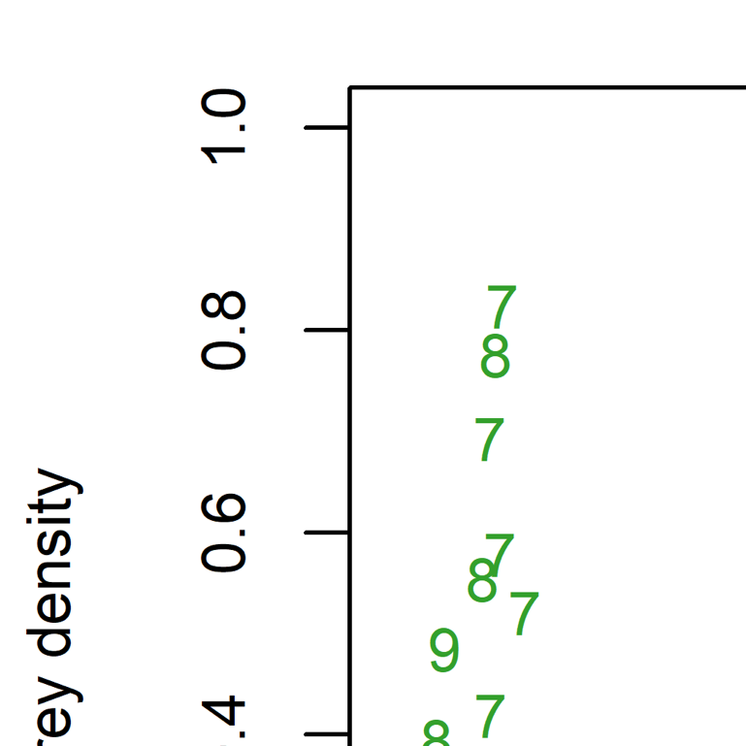

Fig. 5 Relationship between sea stars and their prey on 30x2m transects at five sites. *Henricia* spp. were excluded because they eat sponges and bacteria. Numbers in the top figure are the year of the survey (ie, 9 = 2019).

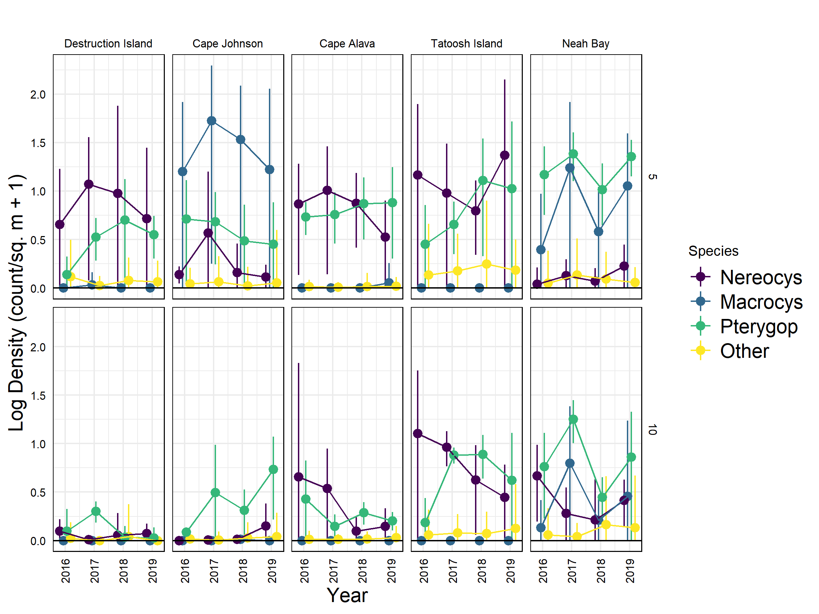

Fig. 6 Abundance of macroalgae on 60 x 2 m transects at each sites and at two depths (5 and 10 m). Values are the log(stipes m-2 +1). MORE

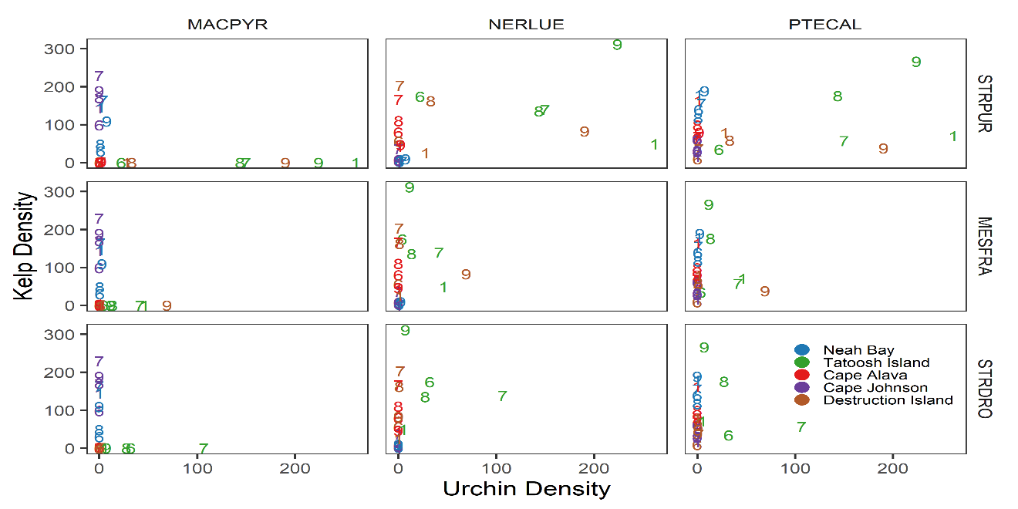

Fig. 7 Relationships between the density of canopy and understory kelps and the abundance of purple and red urchins. MACPYR = *Macrocystis pyrifera*, NERLUE = *Nerocystis luekana*, PTECAL = *Pterygophora californica*, and OTHER = other macroalgae*.* Numbers indicate the year of survey (e.g., 9 = 2019).

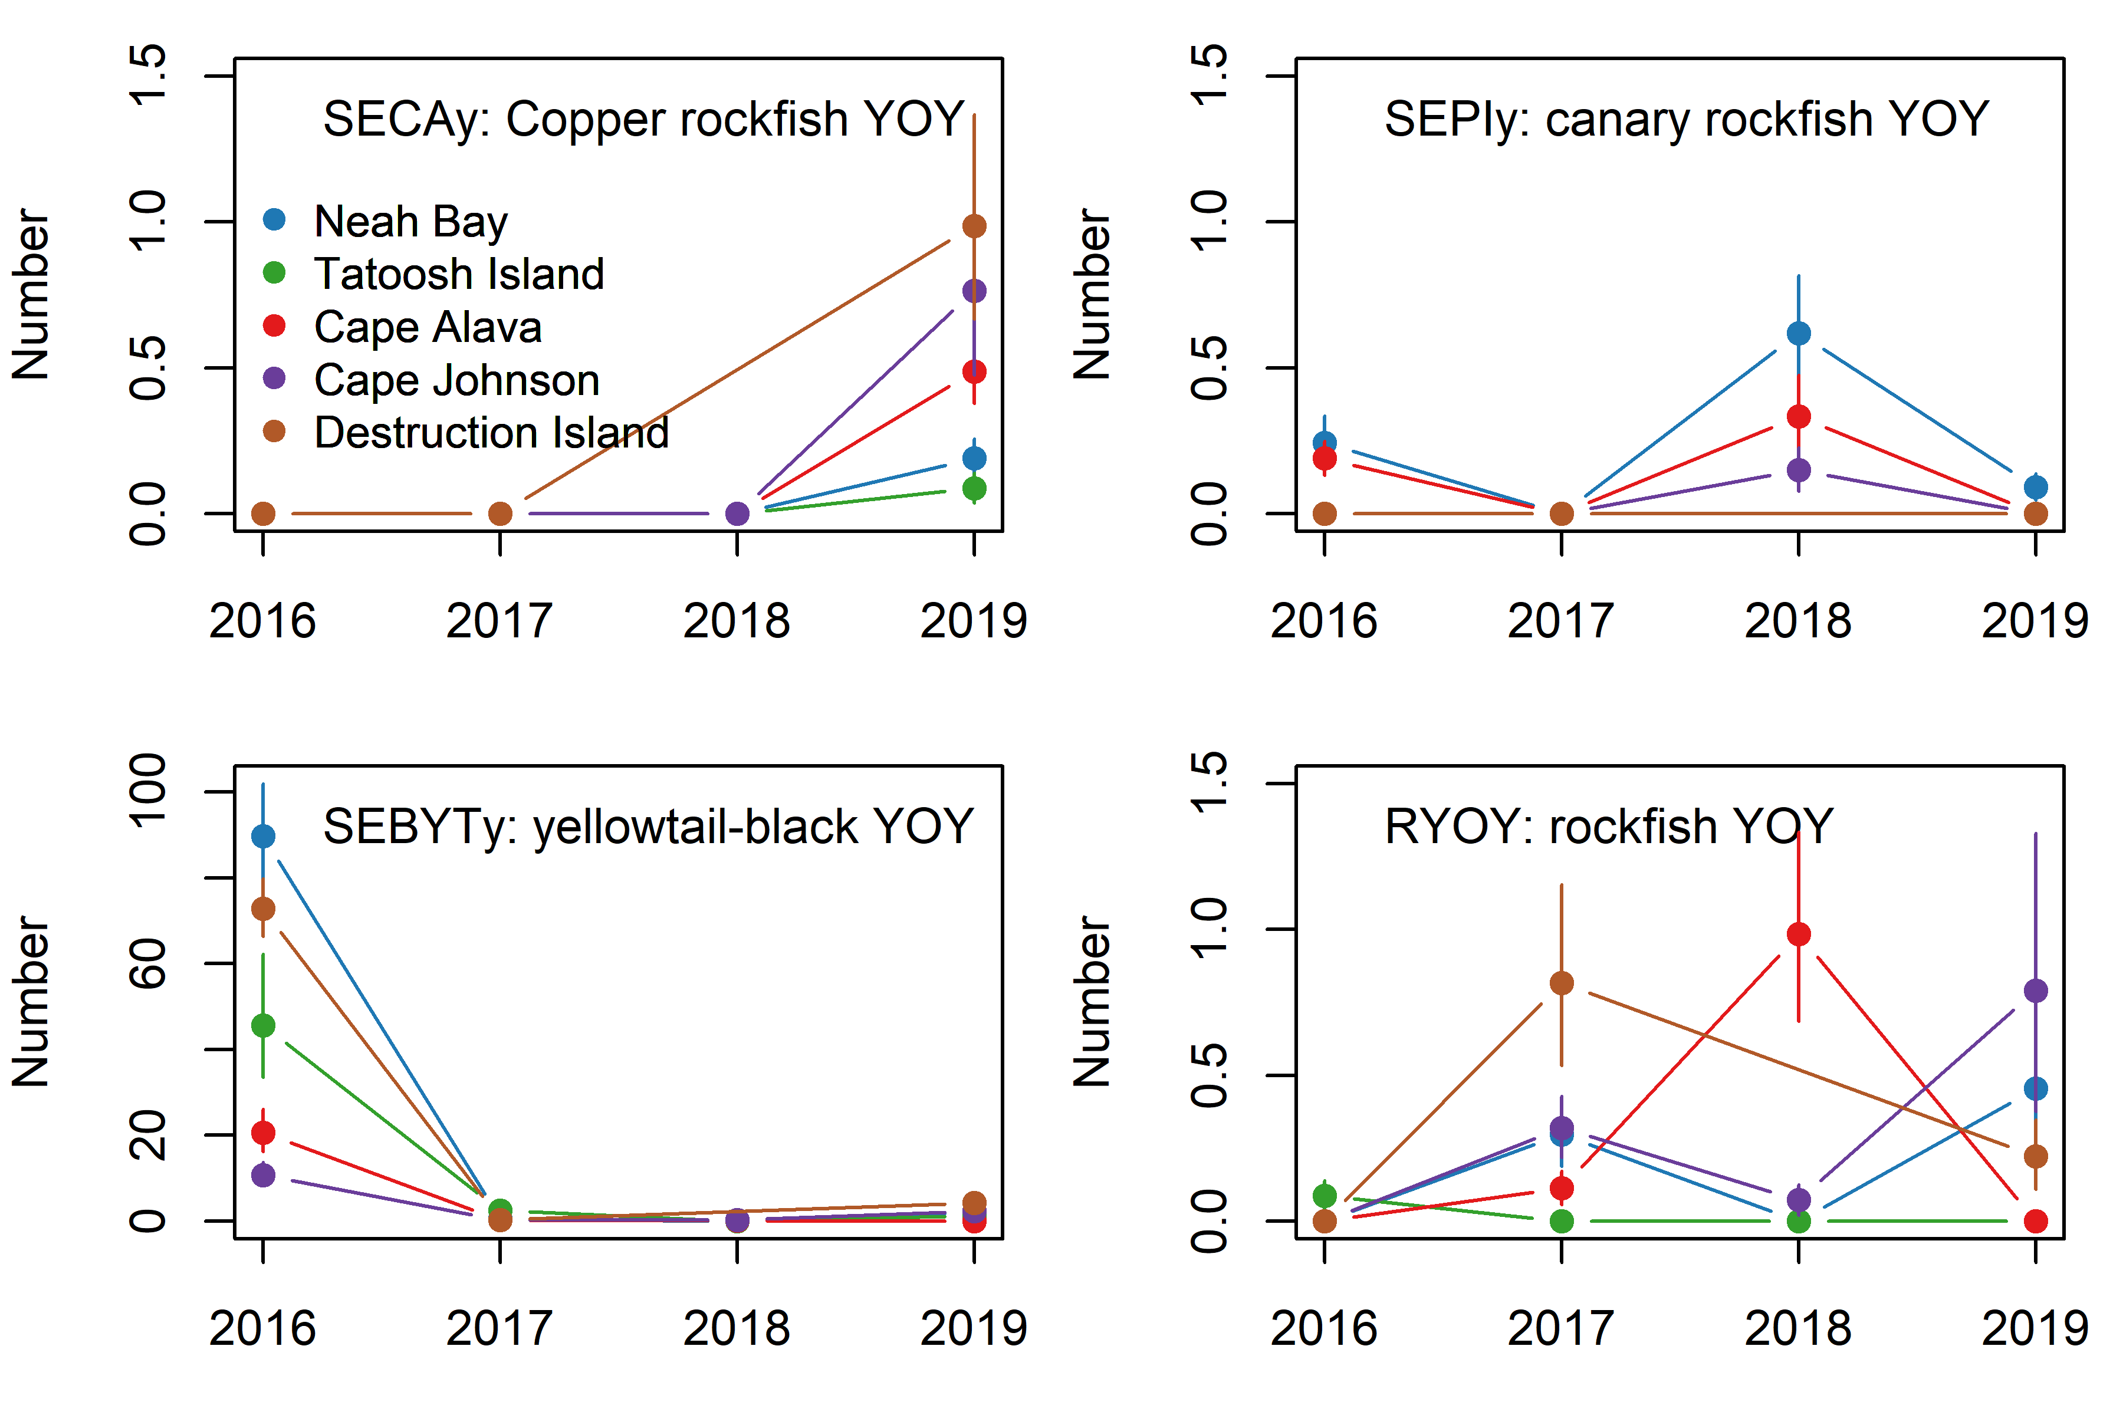

Fig. 8 Abundance of rockfish recruits (young-of-year, YOY) by site and year. Data are the back-calculated site x year means (log x+1) and s.e. for number of recruits per 30x2-m transect.

# Supplement

## Multivariate ordinations

We used distance-based redundancy analysis (dRDA, implemented via the ‘capscale’ function in R 4.0.2; Legendre and Anderson 1999, R Core Team 2020) to ordinate multivariate patterns and understand relationships between fish or invertebrate community structure and habitat predictor variables (kelp, UPC, and substratum). First, we ordinated transects (fish or invertebrates) among sites to determine whether assemblage structure varied among sites (where site x depth x years were the constraining variables). We then also conducted a second set of ordinations using habitat variables to constrain the ordination. For this second set, we used site x year x depth averages because habitat variables did not map directly to fish or invert transects. In all cases, we square-root transformed the data prior to analysis to reduce the effect of highly abundant (Clarke and Warwick 2001) species and used Bray-Curtis distance. Note, rockfish young-of-year (YOY) were excluded from the analyses due to their ephemeral and highly variable occurence.

The habitat variables matrix included kelp density, biotic habitat, and substratum characteristics. For kelp density, we included the stipe counts for four taxa *M. pyrifera, N. luekana* , *P. californica,* and ‘other’ macroalgae. For the biotic habitat and the substratum data, we first conducted separate principal components analyses (PCA) to reduce the number of variables entering into dRDA above and to understand variation among sites and depths. We used the first two PCA axes from each analysis in the above dRDAs after averaging each by site x year x depth.

## Multivariate results

For the PCA of biotic benthic habitat, the first PC separated transects with red versus brown algae (Fig. S 3). The second PC distinguished among transects with encrusting species and non-mobile invertebrates from those with more red or brown algae. Thus PC2 gives an indication of understory algal coverage. There was no clear separation of sites within this ordination, however.

The PCA of abiotic substratum characteristics (Fig. S 4) separated transects of primarily bedrock from those with boulder structure along the first PC. Destruction Island and Tatoosh Island had more bedrock than other sites, while Cape Johnson and Cape Alava had more boulder or cobble habitat. The second PC explained differences among transects in slope (0-10 cm vs 10 cm – 1 m drop over the 2-m width of the transect). This second PC did not appear strongly associated with sites or depths.

Fish assemblages (Fig. S 5) differed among sites, depths, and years (dRDA, p < 0.001, Fig. 2

Fig. 2). While there was variation among years for all sites, Cape Johnson ordinated separately from Cape Alava. Neah Bay and Tatoosh Island were intermediate between the previous two while Destruction Island assemblages were highly variable through time. Some species like black rockfish (SEME) were found at all sites (Fig. S 5) and did not distinguish among sites in the ordination. Others like tubesnout (AUFL) were abundant at a subset of sites in 2016 and to a lesser extent in 2019. Greenlings (HEXA), copper rockfish (SECA), China rockfish (SENE), lingcod (OPEL), and cabezon (SCMA) characterized Cape Alava and Neah Bay, with the exception of 2016. Surfperch (EMBI) were also common at Cape Alava and at Cape Johnson, but only in 2017 and 2018 for the latter.

The fish assemblage did not show strong correlation with the combined kelp-biotic-substrate habitat matrix (dRDA , p > 0.05, Fig. S 7). This is not entirely surprising given Cape Alava and Cape Johnson, which had dissimilar fish assemblages (Fig. 2), had similar biotic benthic habitats (Fig. S 4). Moreover, given that all transects were done in somewhat sheltered kelp forests, the habitat may not have varied significantly among sites from the point of view of a fish. Large scale factors (circulation, settlement, etc) may have been more important in driving differences in fish assemblages among sites.

The invertebrate assemblages (Fig. S 8, Fig. S 9, Fig. S 10, Fig. S 11) showed a clear separation of sites, especially when factors were averaged by site and year (dRDA, p < 0.001, Fig. 3). While there was some variation among years, it was much less than the spread among sites. Tatoosh Island was notable for having more urchins (Axis 1) than other sites. Urchins also characterized Destruction Island and Neah Bay relative to other sites but were much less common at these two sites than at Tatoosh Island. Tunicates, leather stars, large barnacles and orange cucumbers were more common at Tatoosh Island, Destruction Island, and Cape Alava that at Neah Bay, and at Cape Johnson in 2017 and 2018 than in 2016 and 2019.

Associations between macroinvertebrates and habitat features were largely driven by urchins and Tatoosh Island (Fig. S 13). All three urchin species loaded positively on the first axis indicating positive associations with brown understory algae, *N. leukana*, *P. californica,* and other macroalgae and areas with boulder habitat.

## Supplement table

Table S 1. List of fish species observed on visual surveys. Taxa were lumped into Group for statistical analyses. Note, rockfish young-of-year (YOY) were excluded from the ordinations due to their ephemeral nature.

|  |  |  |
| --- | --- | --- |
| **Species** | **Common name** | **Group** |
| *Aulorhynchus flavidus* | tubesnout | AUFL |
| bait-sardines-anchovy | bait | BAIT |
| *Brachyistius frenatus* | kelp surfperch | EMBI |
| Clupeidae | herring | BAIT |
| *Cymatogaster aggregata* | shiner surfperch | EMBI |
| *Embiotoca lateralis* | striped surfperch | EMBI |
| Embiotocidae | surfperches | EMBI |
| *Engraulis mordax* | northern anchovy | BAIT |
| *Hemilepidotus hemilepidotus* | red irish lord | HEXA |
| *Hexagrammos spp* | greenlings | HEXA |
| *Hexagrammos decagrammus* | kelp greenling | HEXA |
| *Hexagrammos lagocephalus* | rock greenling | HEXA |
| *Hexagrammos stelleri* | whitespotted greenling | HEXA |
| *Ophiodon elongatus* | lingcod | OPEL |
| *Oxylebius pictus* | painted greenling | HEXA |
| *Rhacochilus vacca* | pile perch | EMBI |
| *Sardinops sagax* | Pacific sardine | BAIT |
| *Scorpaenichthys marmoratus* | cabezon | SCMA |
| *Sebastes caurinus* | copper rockfish | SECA |
| *Sebastes caurinus YOY* | copper rockfish yoy | SECAy |
| *Sebastes melanops/flavvidus YOY* | yellowtail-black yoy | SEBYTy |
| *Sebastes melanops* | black rockfish | SEME |
| *Sebastes melanops YOY* | black rockfish yoy | SEMEy |
| *Sebastes mystinus* | blue rockfish | SEMY |
| *Sebastes nebulosus* | China rockfish | SENE |
| *Sebastes pinniger YOY* | canary rockfish yoy | SEPIy |
| *Sebastes YOY* | rockfish yoy | RYOY |

## Supplement Figures

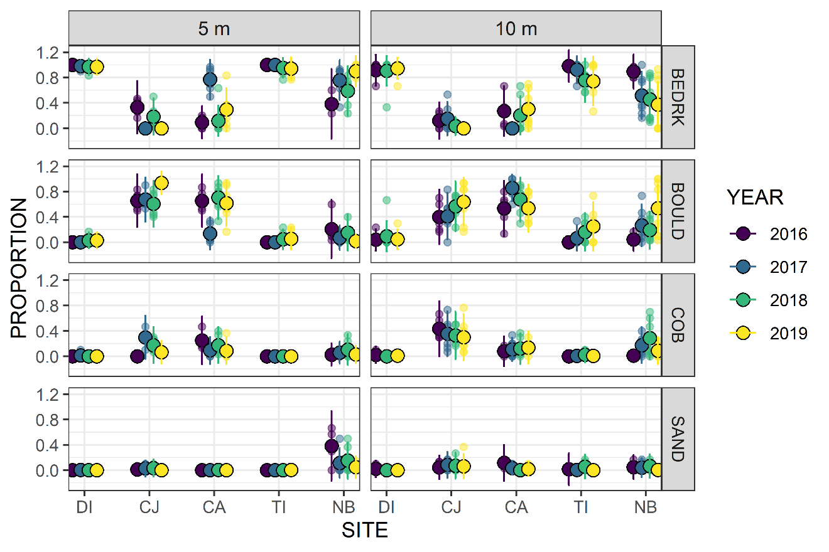

Fig. S 1 Substratum characteristics by site year and depth. BEDRK = bedrock, BOULD = boulder, COB = cobble, SAND = sand.

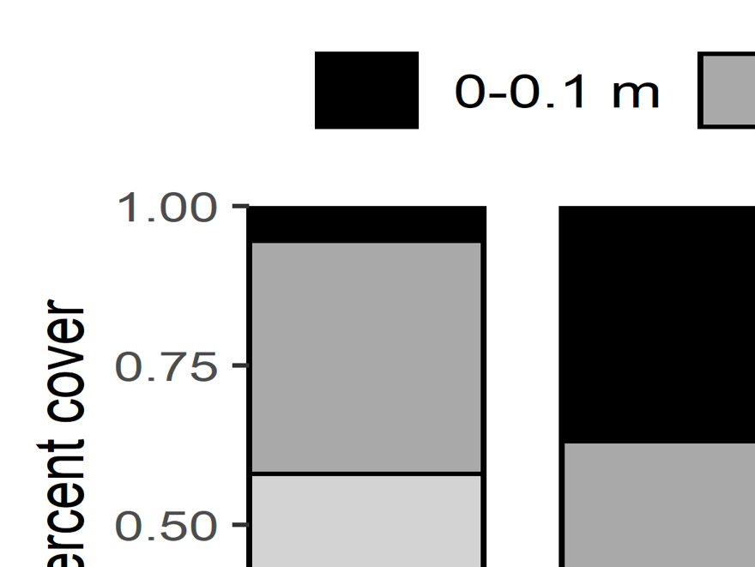

Fig. S 2 Estimate of slope sites, summarized across depths and years. Ranges are the drop in elevation across the width of a 2-m transect. Data are the average of XX measurements per 30-m transect.

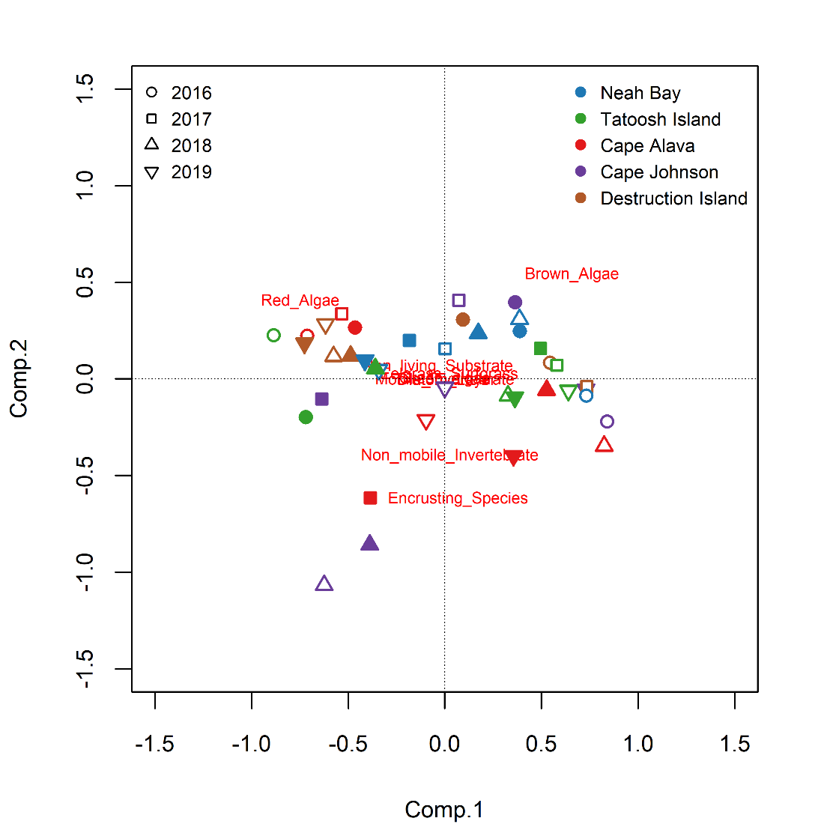

Fig. S 3 Results of a principal components analysis ordinating biotic benthic habitat by site x year x depth. Open and closed symbols indicate 5-m and 10-m transects, respectively.

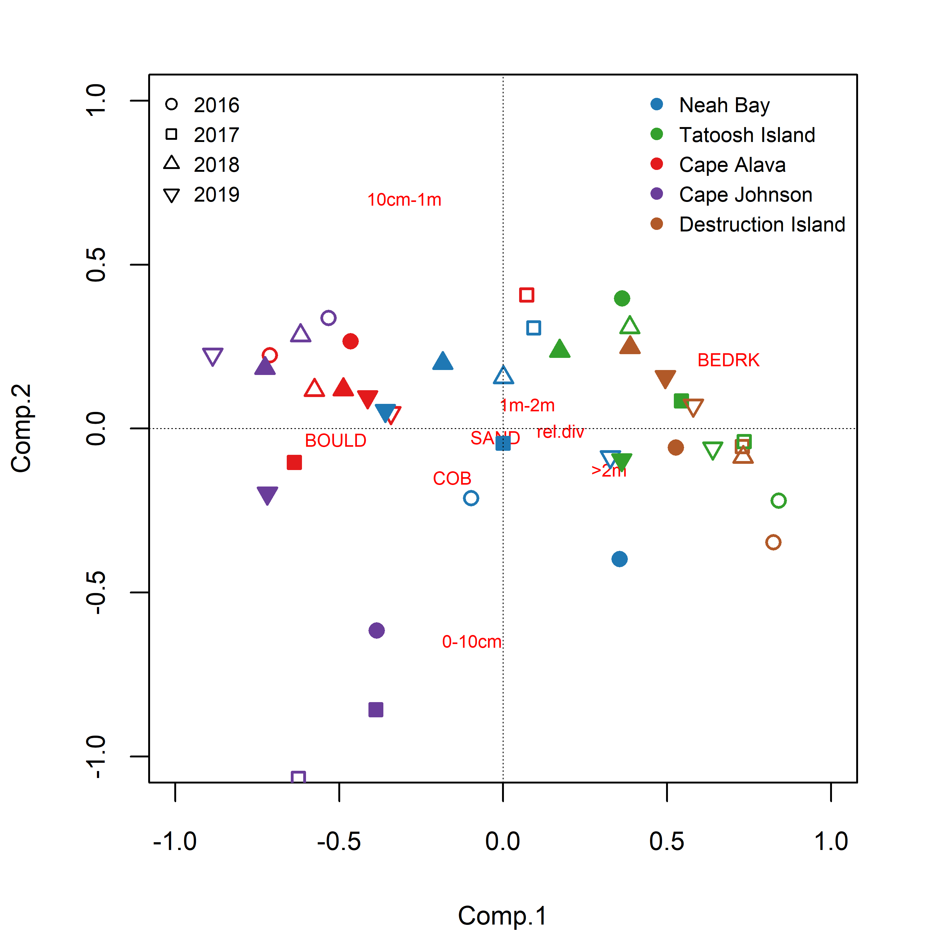

Fig. S 4 Principal components analysis of abiotic substratum characteristics by site x year x depth. Open and closed symbols indicate 5-m and 10-m transects, respectively. BEDRK = bedrock, COB = cobble, BOULD = boulder, SAND = sand; distance ranges (e.g., 1 m – 2 m) indicate the high mean high difference across the 2-m width of the transect – a measure of slope.

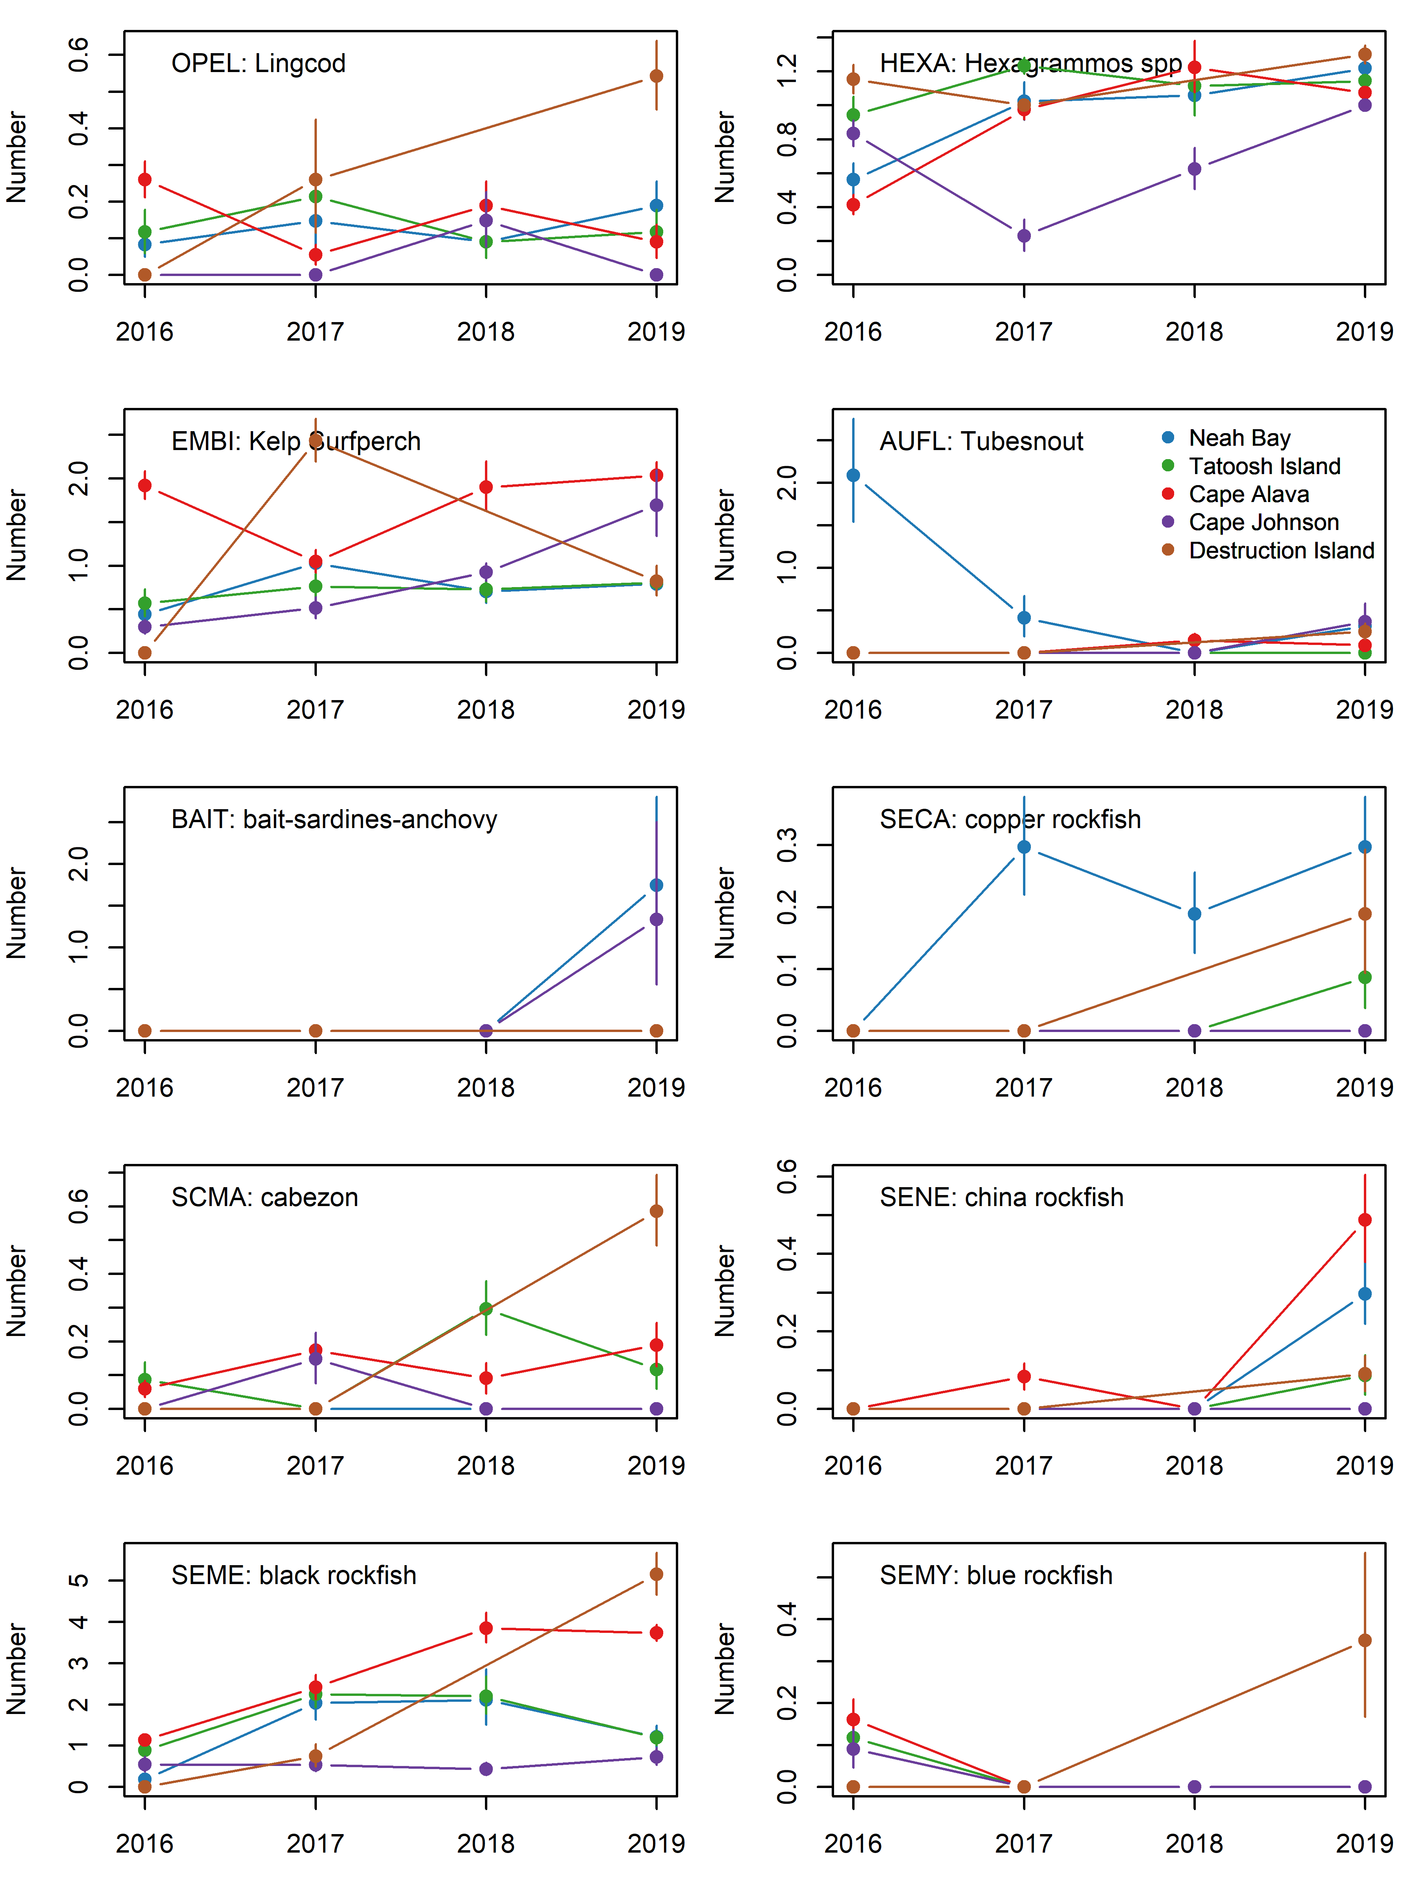

Fig. S 5 Abundance of the primary fish species seen on at five sites from 2016-2019. Data are the back-calculated site x year means (log x+1) and s.e.

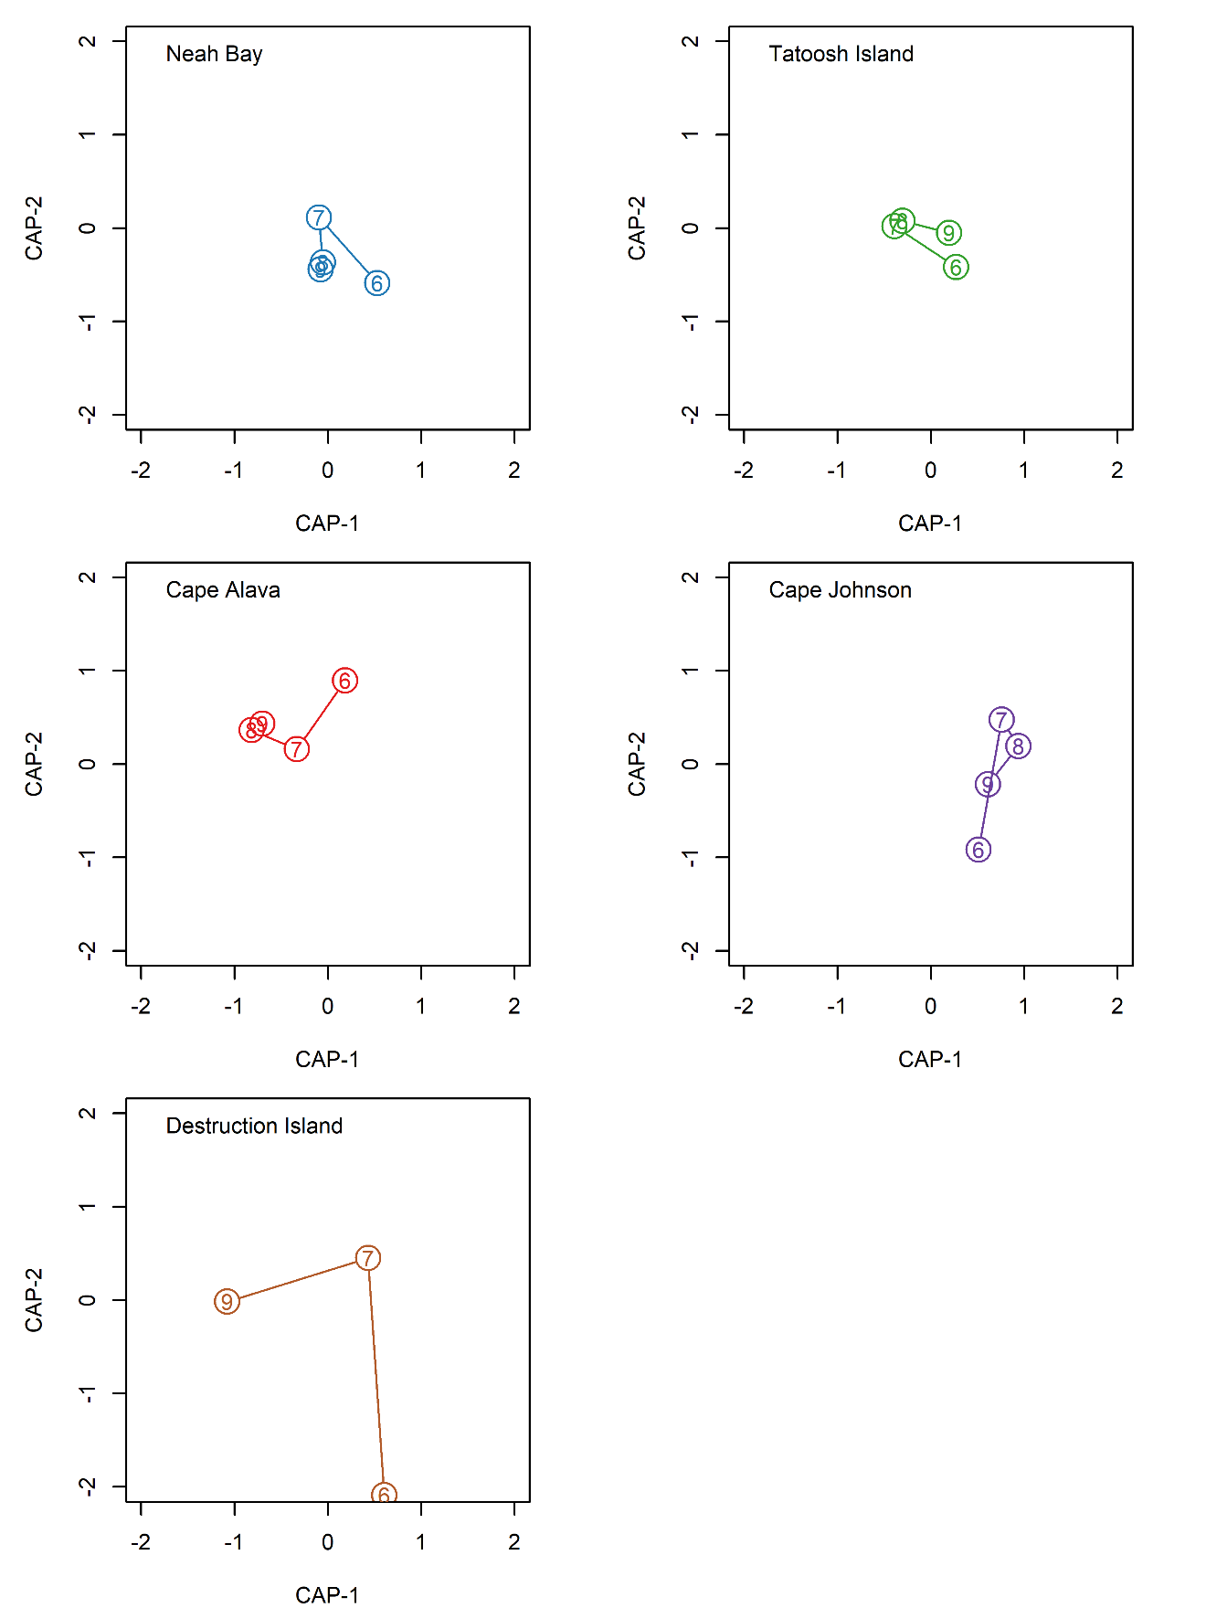

Fig. S 6 Ordination of sites based on the fish taxa present on 30 x 2 m transects from a distanced-based redundancy analysis. The analysis used individual transects, but the axes were averaged by site and year for clarity in the presentation. Numbers are the years (9 = 2019) for sampling.

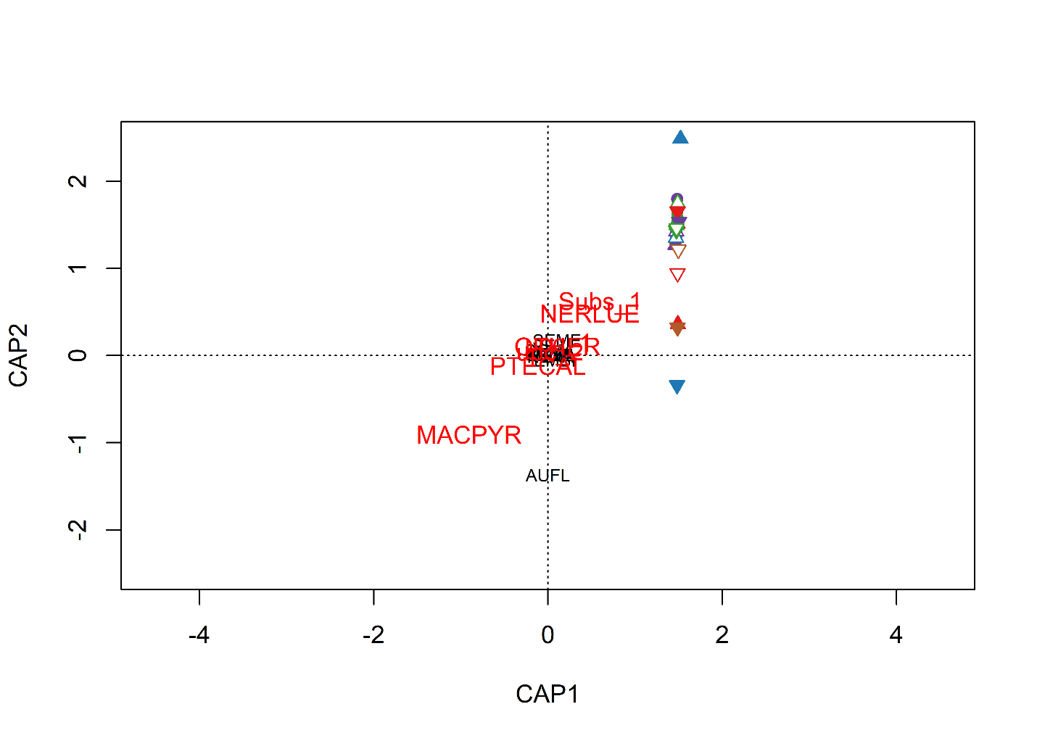

Fig. S 7 Results of distance-based redundancy analysis with fish species assemblages constrained by kelp, bioitic benthic habitat, and substratum variables. The ordination was non-significant (p > 0.05).

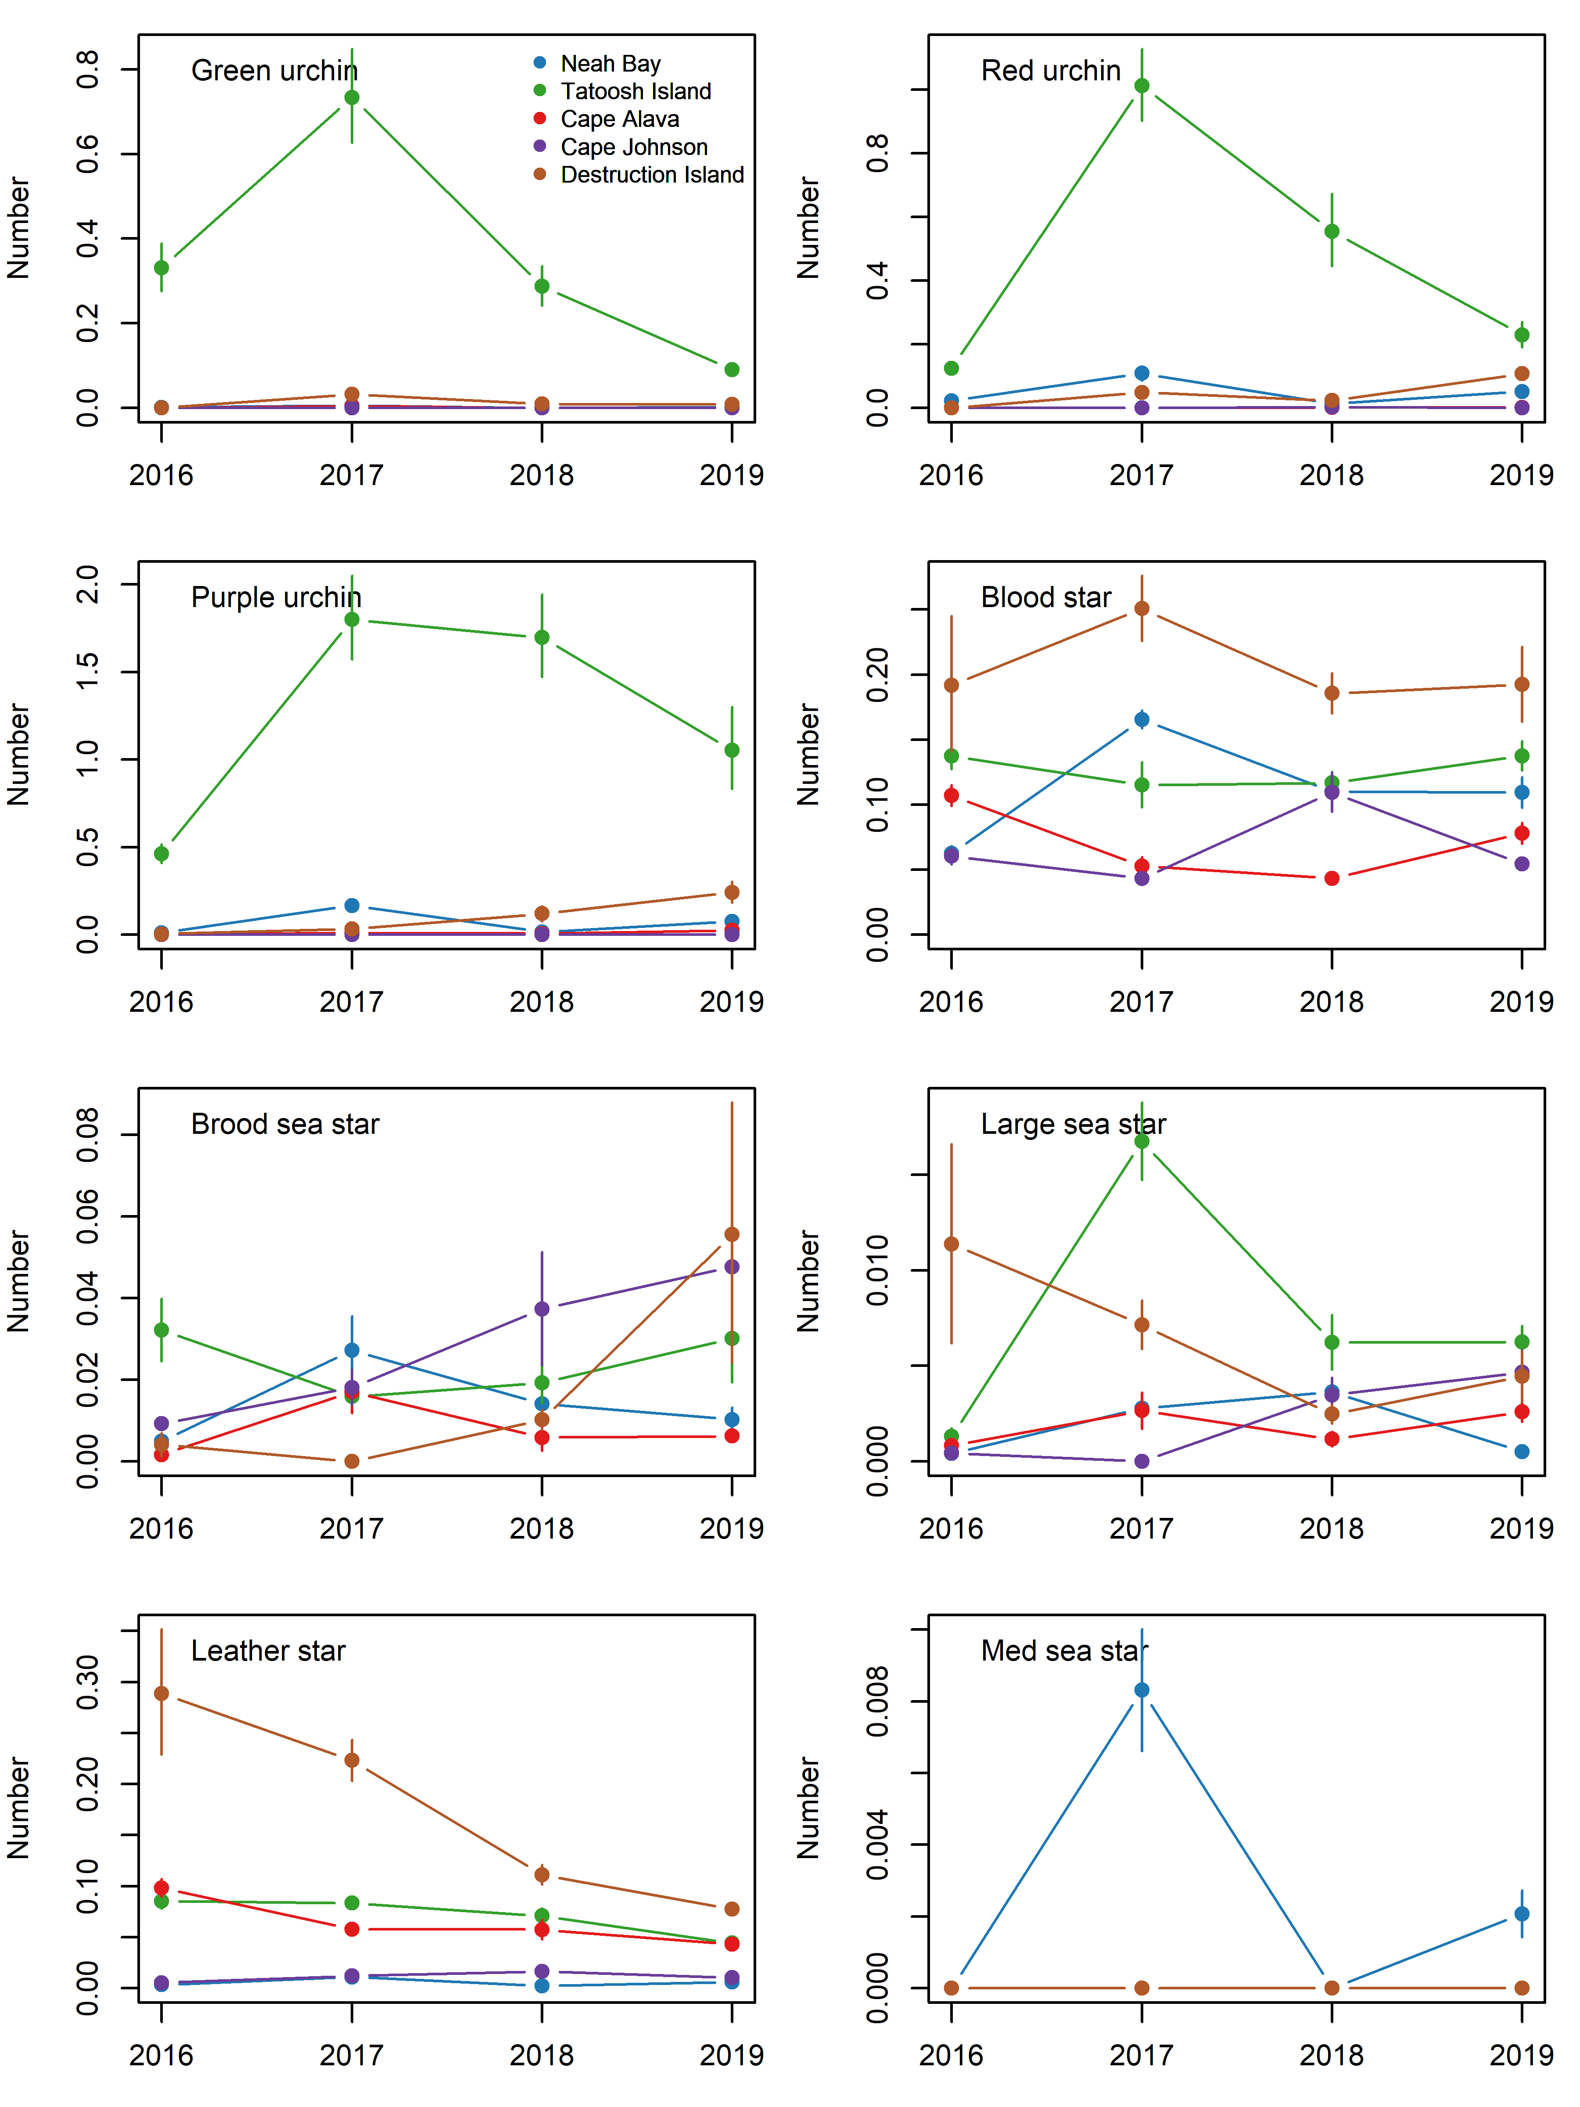

Fig. S 8 Abundance of the primary invertebrate species seen on at five sites from 2016-2019. Data are the back-calculated site x year means (log x+1) and s.e. Large sea stars include: *Evasterias troschelii* (99)*, Orthasterias koehleri* (62)*, Pisaster brevispinus* (7)*, Pisaster giganteus* (1)*, Pycnopodia helianthoides* (8)*,* and *Solaster stimpsoni* (14)*.* Medium sea stars include: *Crossaster papposus* (1)*, Mediaster aequalis* (7)*, and Patiria miniata* (135). Numbers in parentheses are the total observed from 2016-2019.

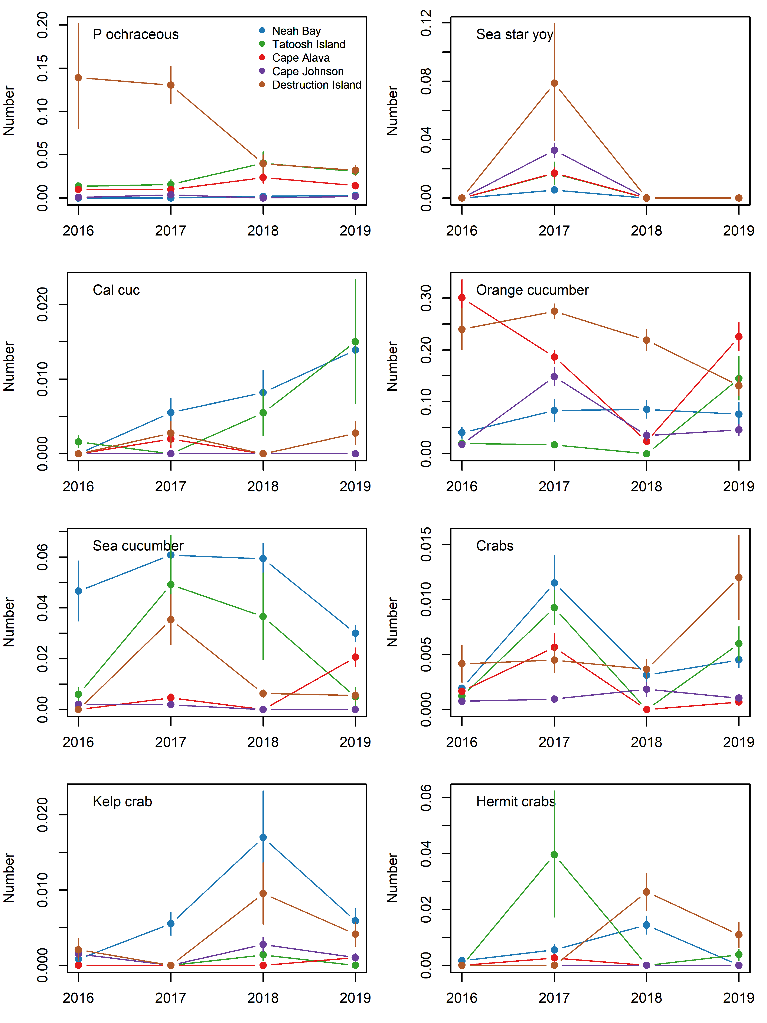

Fig. S 9 Abundance of the primary invertebrate species seen on at five sites from 2016-2019. Data are the back-calculated site x year means (log x+1) and s.e. Note, the for seastar YOY the value for Cape Alava overlaps that of Tatoosh Island in 2017.

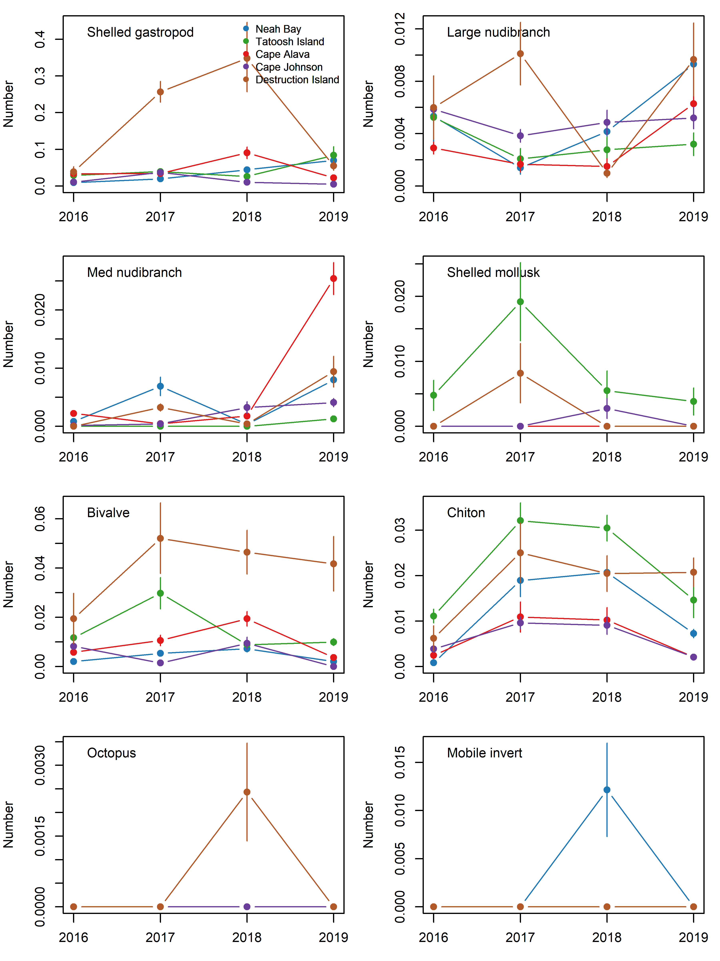

Fig. S 10 Abundance of the primary invertebrate species seen on at five sites from 2016-2019. Data are the back-calculated site x year means (log x+1) and s.e.

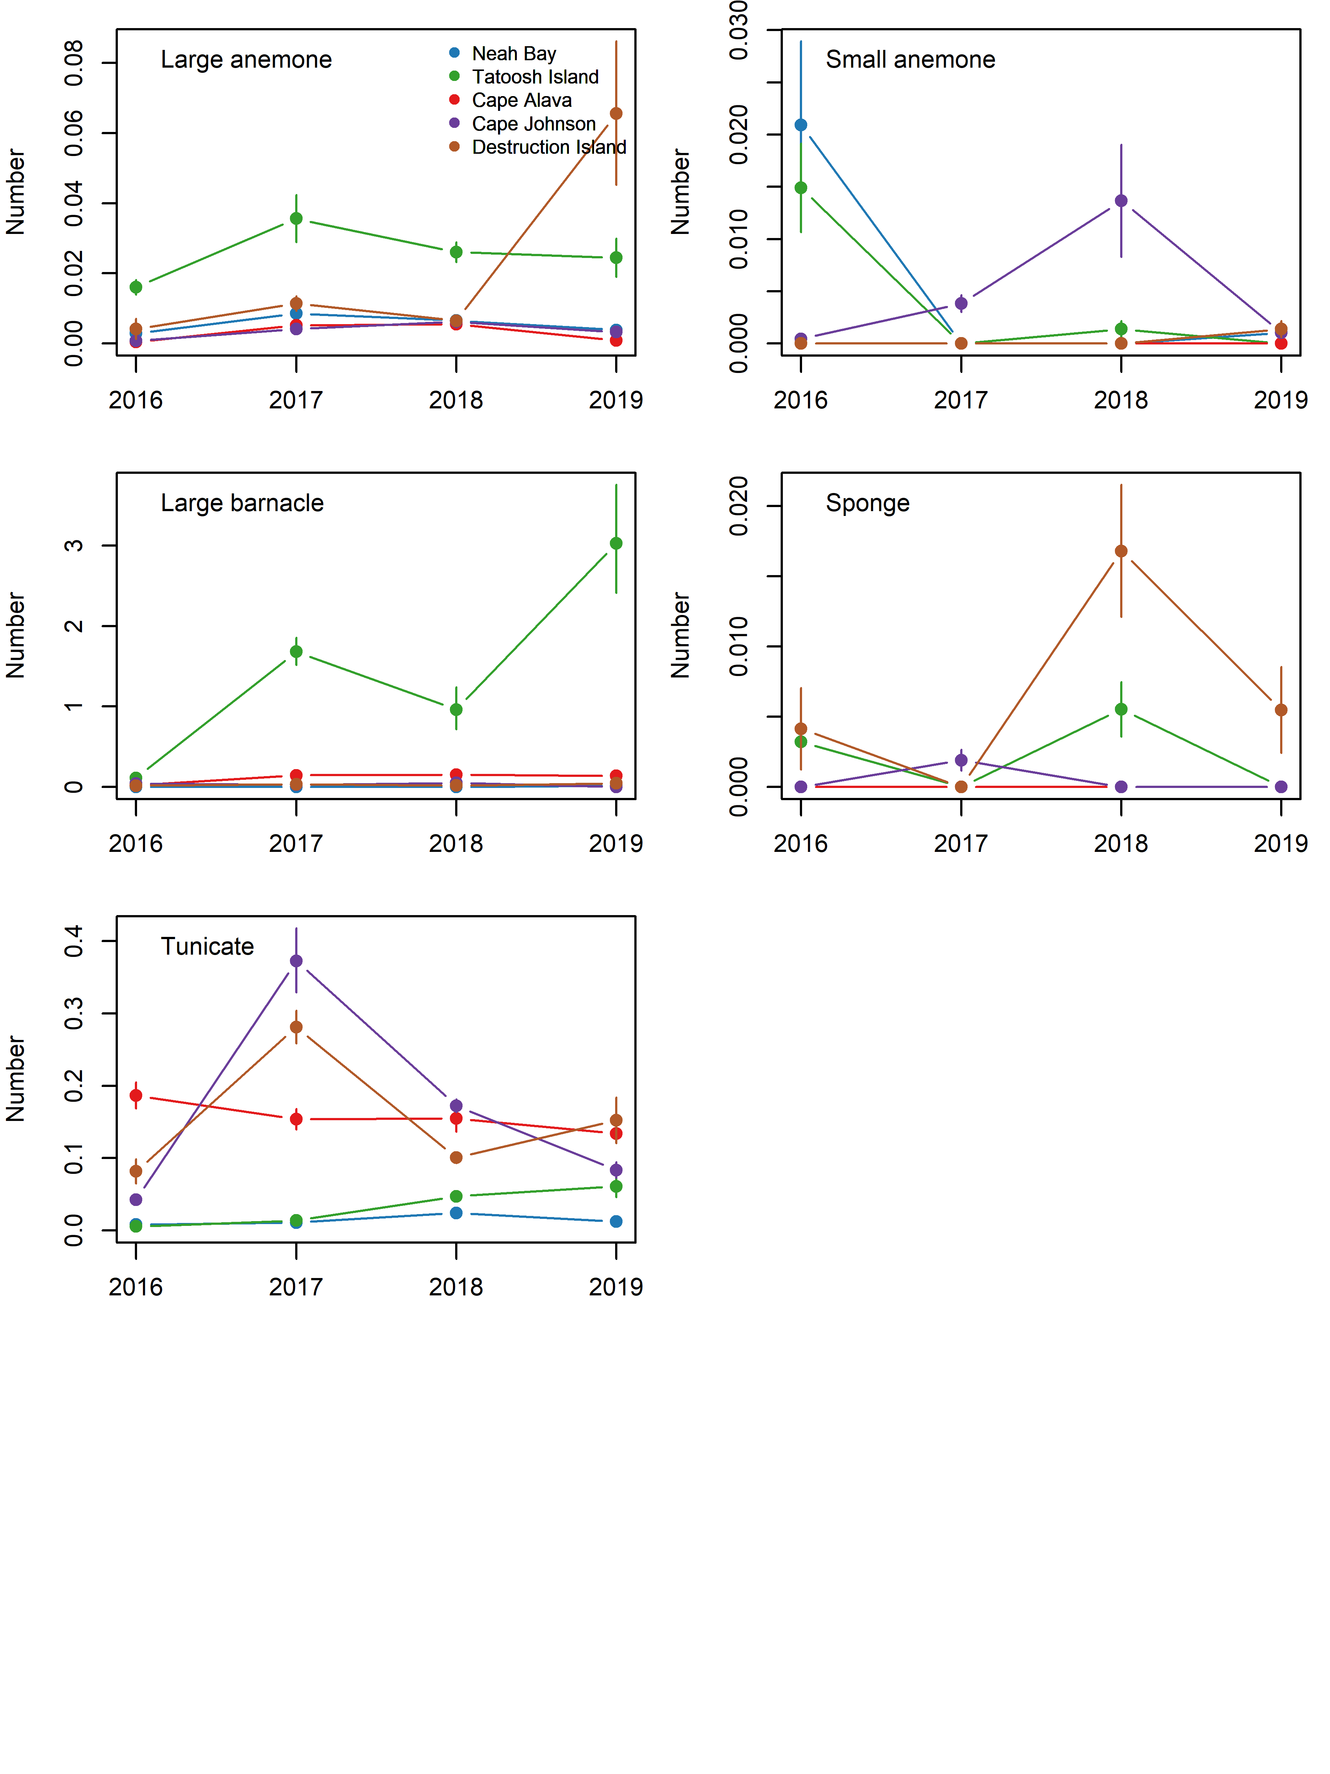

Fig. S 11 Abundance of the primary invertebrate species seen on at five sites from 2016-2019. Data are the back-calculated site x year means (log x+1) and s.e.

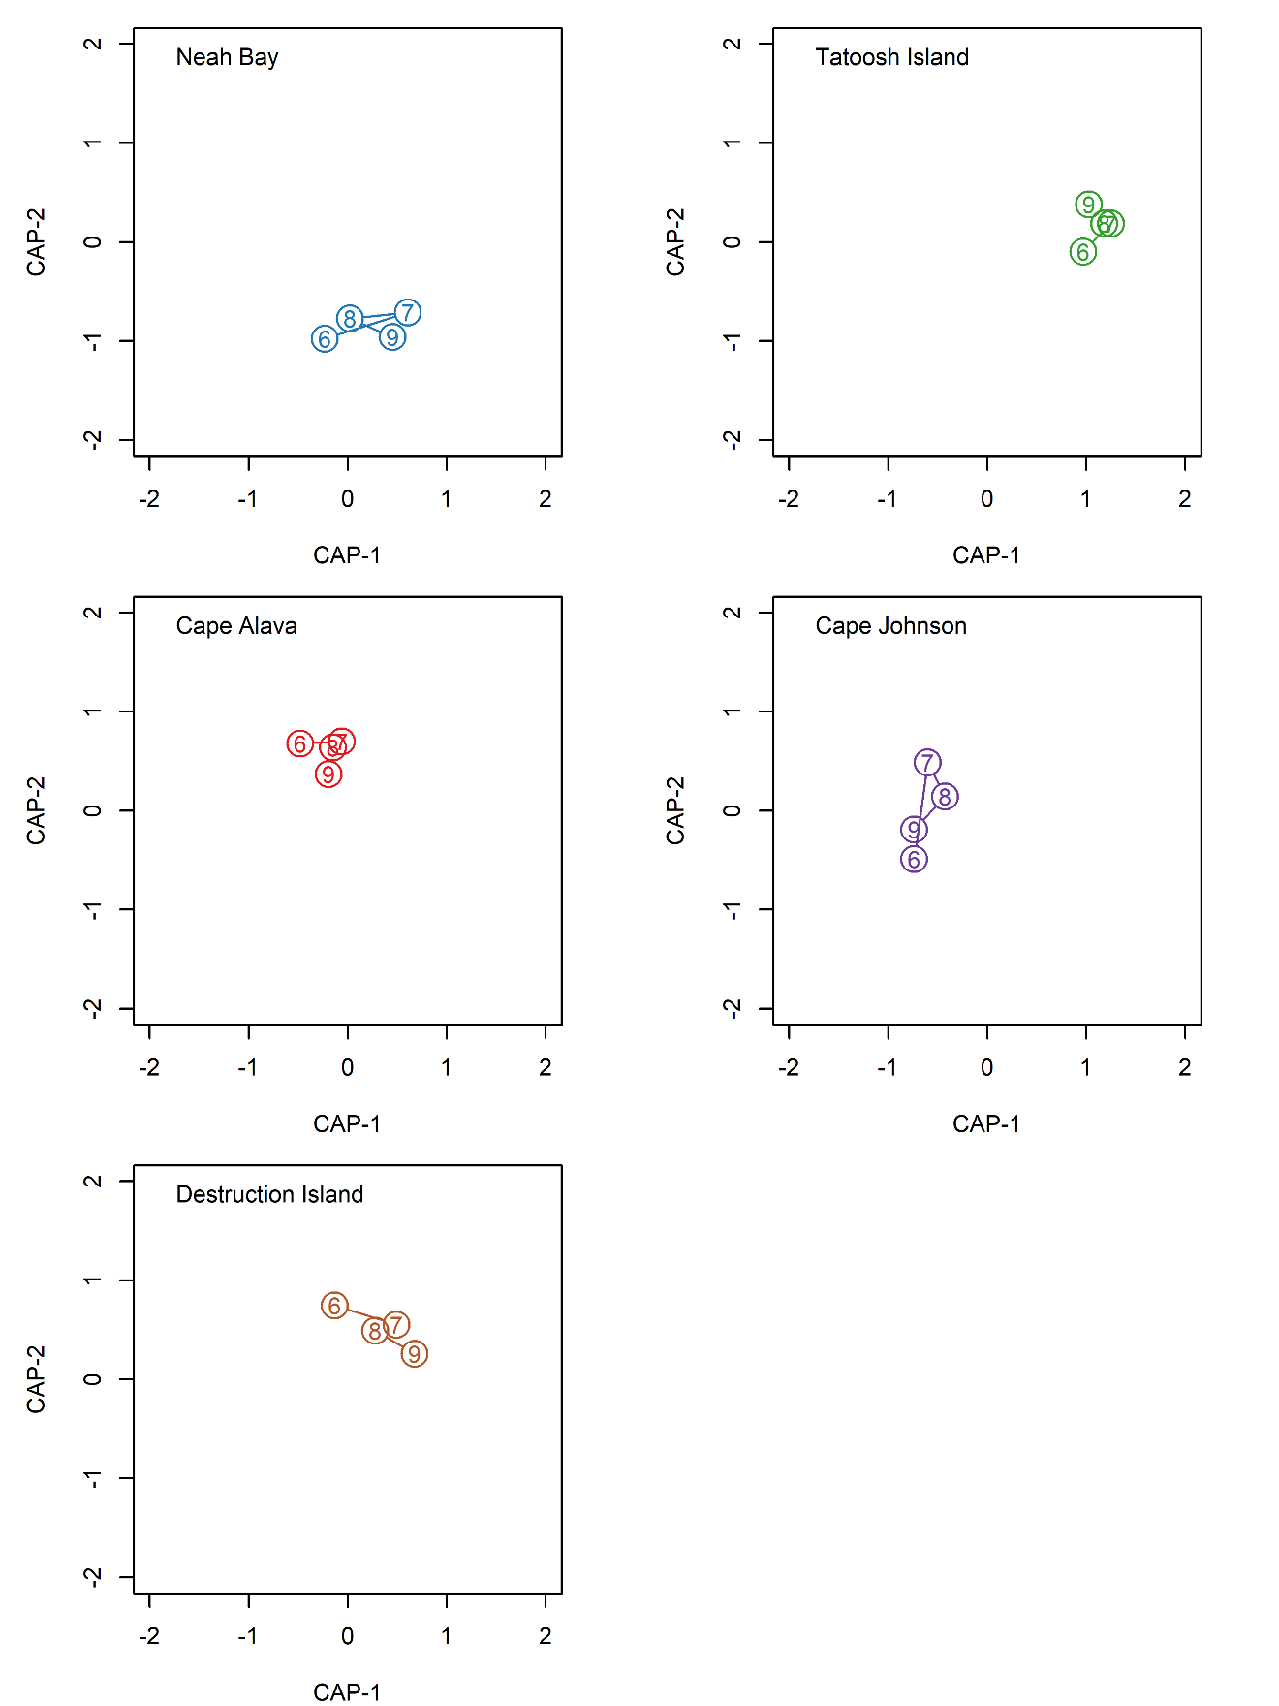

Fig. S 12

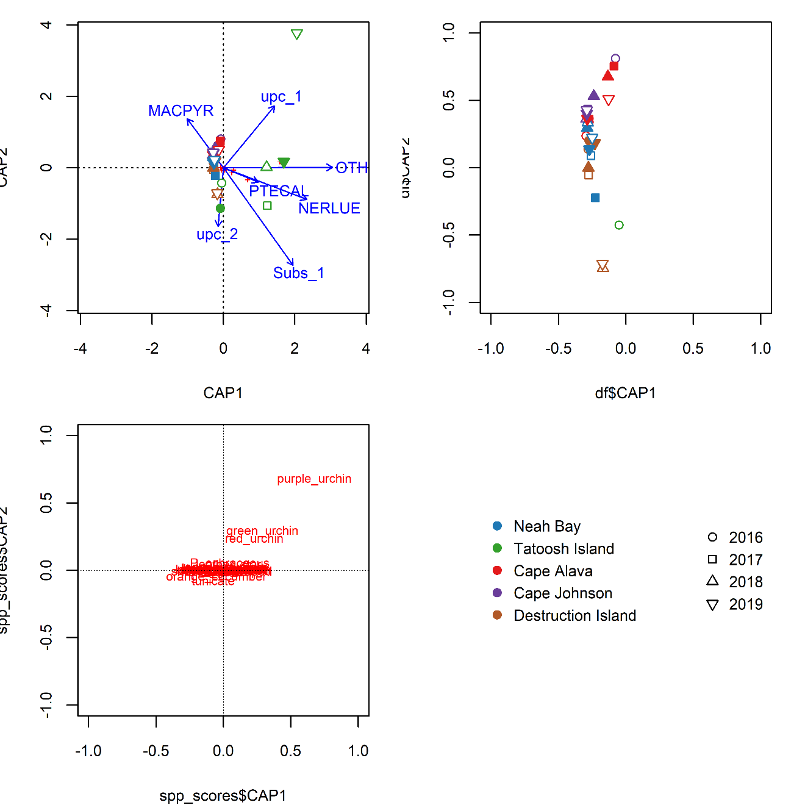

Fig. S 13 Inverts vs habitat CAP MACPYR = *Macrocystis pyrifera*, NERLUE = *Nerocystis luekana*, PTECAL = *Pterygophora californica. Update after updating names in figure FIX axis labels.*

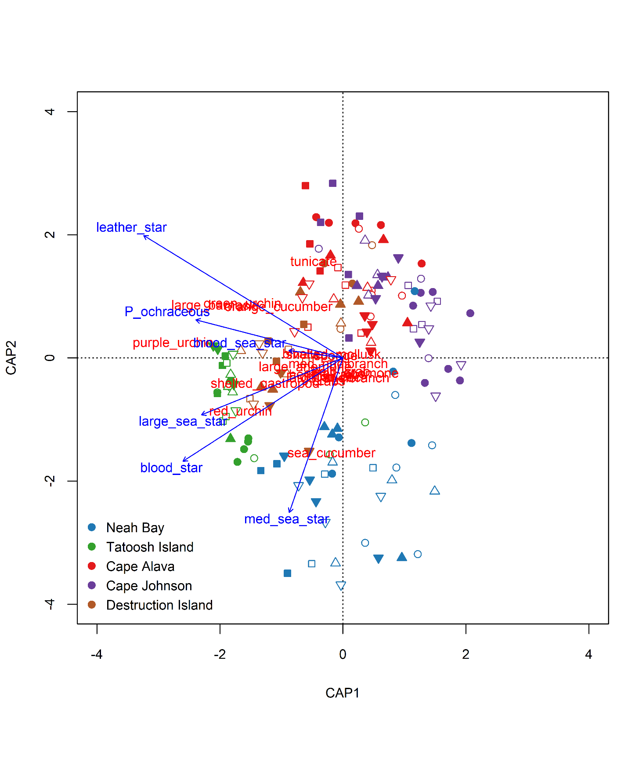

Fig. S 14 Ordination (dRDA) of sea stars versus their potential prey items.

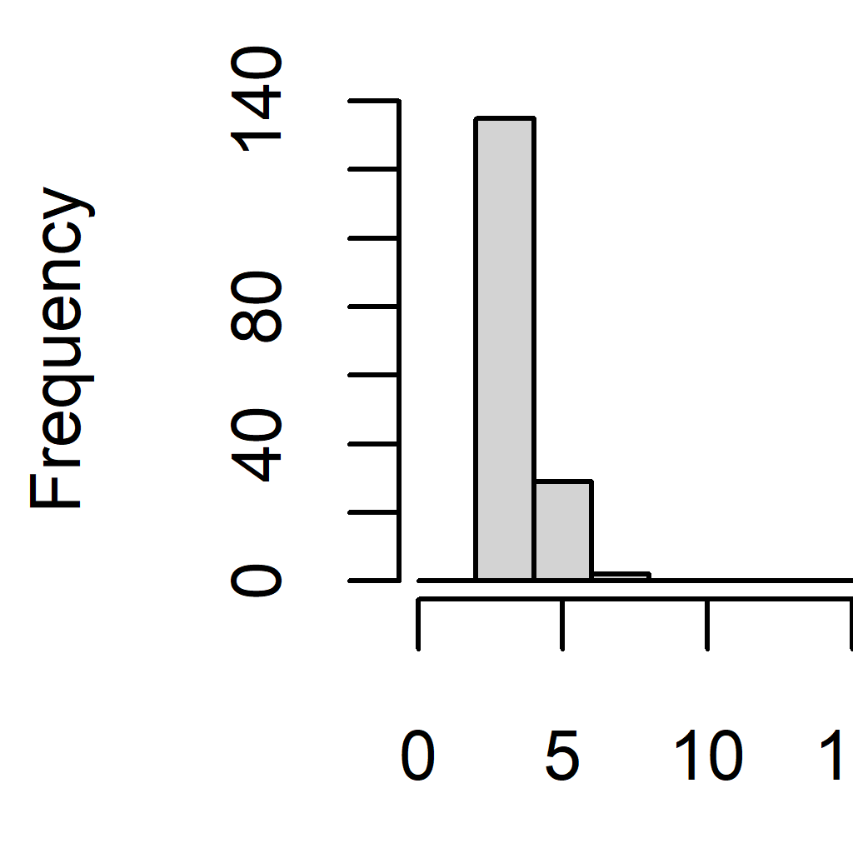

Fig. S 15 Urchin test diameters (mm) for 2018-2019 at Tatoosh Island, WA. Note that the y-axes vary.